# Rank Advancement Ceremony

**Scout**  Michael Alberti Jessie Bishop

Allan Chu Patrik Dalia

Matt Gassenheimer Justin Lipins Brandon Luong Luke Rizzuto

Zack Rosenberg Dean Scola

**Tenderfoot** Patrick Holland Tay Hlaing Matthew Lim David Soffer

**2nd Class** Daniel Gassenheimer Charles Rizzuto Matthew Lim

**1st Class** Daniel Casal John DeJesu Michael Rosenberg

**Star** Evan Licari Ian O'Neill

Jared Garfinkel Daniel Reilly

**Life** Anthony Schiano

# Merit Badges

Michael Balesh

Search & Rescue, Codes & Signals, Fire Safety

Noah Fox

Communication*

Jared Garfinkel

Cooking*, Communication

Henry Lumerman

Cit in World*, Cit in Nation*, Personal Management*

Zack Mertz

Camping*

* Merit badge required   
 for Eagle Rank

# Troop Officers

Senior Patrol Leader Ian O’neill

Asst. Senior Patrol Leader Anthony Schiano

Asst. Senior Patrol Leader Aaron Waltzer

Den Chief David Savarino  
 Michael Synnott

Troop Historian Michael Synnott

Troop Librarian Daniel Casal

Troop Quartermaster Robert Casal  
Anthony Schiano  
Jared Garfinkel

Troop Scribe Daniel Reilly

Troop Bugler Jared Garfinkel

Troop Webmaster Jackson Sussman

Junior Assist. Scoutmaster Noah Fox  
 Henry Lumerman  
 Alex Silberman

# Patrols

Dragon Patrol:PL: Michael Synnott APL: Robert Casal

Falcon Patrol:   
PL: Daniel Gassenheimer APL: Sam Chon

Bull Patrol:   
PL: David Soffer APL: Tay Hlaing

Radioactive Gummy Bear Patrol:  
PL: Jessie Bishop APL: Michael Alberti

# Troop Committee

Activities Dvorah Lumerman

Advancement Patrick Reilly

Advancements Dave Sussman

Committee BJ Casal

Eagle Advisor Howie Perlman

Hospitality Teresa Schiano

Institutional Head Pastor Eric Olsen

Medical & Training Steven Garfinkel

Popcorn Anthony Schiano

Publicity OPEN

Religious Awards Ellen Lessman

Scouting for Food OPEN

Secretary Donna Licari

Transportation Steven Garfinkel

Travel Coordinator Bob Fox

Treasurer Mary Milana

Uniform Accessories Jean Colberg*  
 David Sussman

* outgoing

# Uniformed Leaders

David Lumerman (SM) Jason Rosenberg

Rich DeJesu John Rizzuto

Ed Gellender Bill Savarino

Dave Lipman Michael Silberman

Doug O'Neill Joseph Synnott

Bob Podewils Bill Waltzer

# Boy Scout Oath

On my honor I will do my best

To do my duty to God and my country

and to obey the Scout Law;

To help other people at all times;

To keep myself physically strong,

mentally awake, and morally straight.

# Boy Scout Law (Emoji version)

# 

# Boy Scout Motto

Be Prepared

# Boy Scout Slogan

Do a Good Turn Daily

# Outdoor Code

As an American, I will do my best to

Be clean in my outdoor manners,

Be careful with fire,

Be considerate in the outdoors, and

Be conservation-minded

# Troop 423

# Court of Honor

# *May 11, 2017*

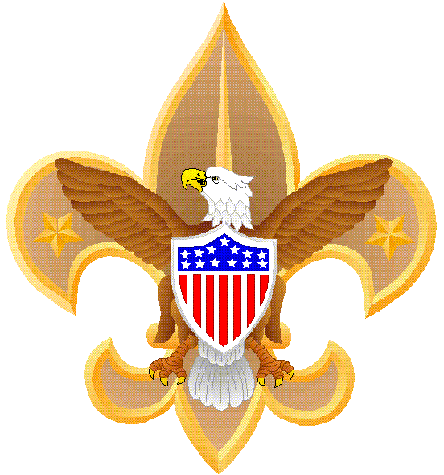

www.troop423pob.org

# Order of Events

Opening Flag Ceremony

Introduction of   
Troop Committee

# Introduction of Troop Uniformed Leaders

# Announcements

Presentation of Merit Badges

Presentation of Awards/Training

Presentation of Rank

Introduction & Installation   
of Patrol Leadership

Scoutmaster Minute

Benediction

Retire the Colors

Dessert is served

