Site 1: First Aid - Reg 7

- Tick bites
- Stings
- Nose Bleed
- Frostbite
- Sunburn

Scouts:
Henry (team lead)
Jackson
Robert Casal
Ethan B.
Theo

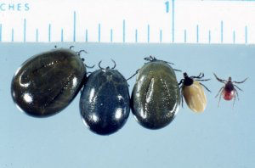
Three fully engorged, one partially engorged, one unengorged female deer ticks. (Photo: James Occi, MA, MS)

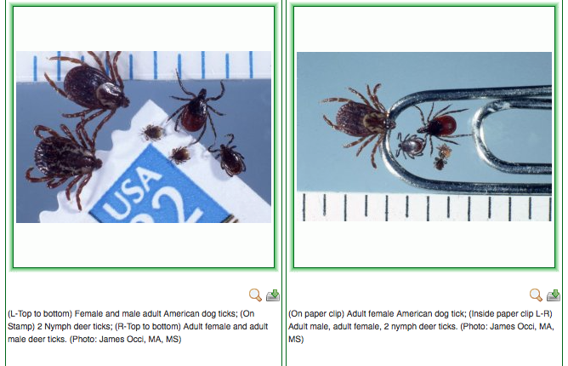
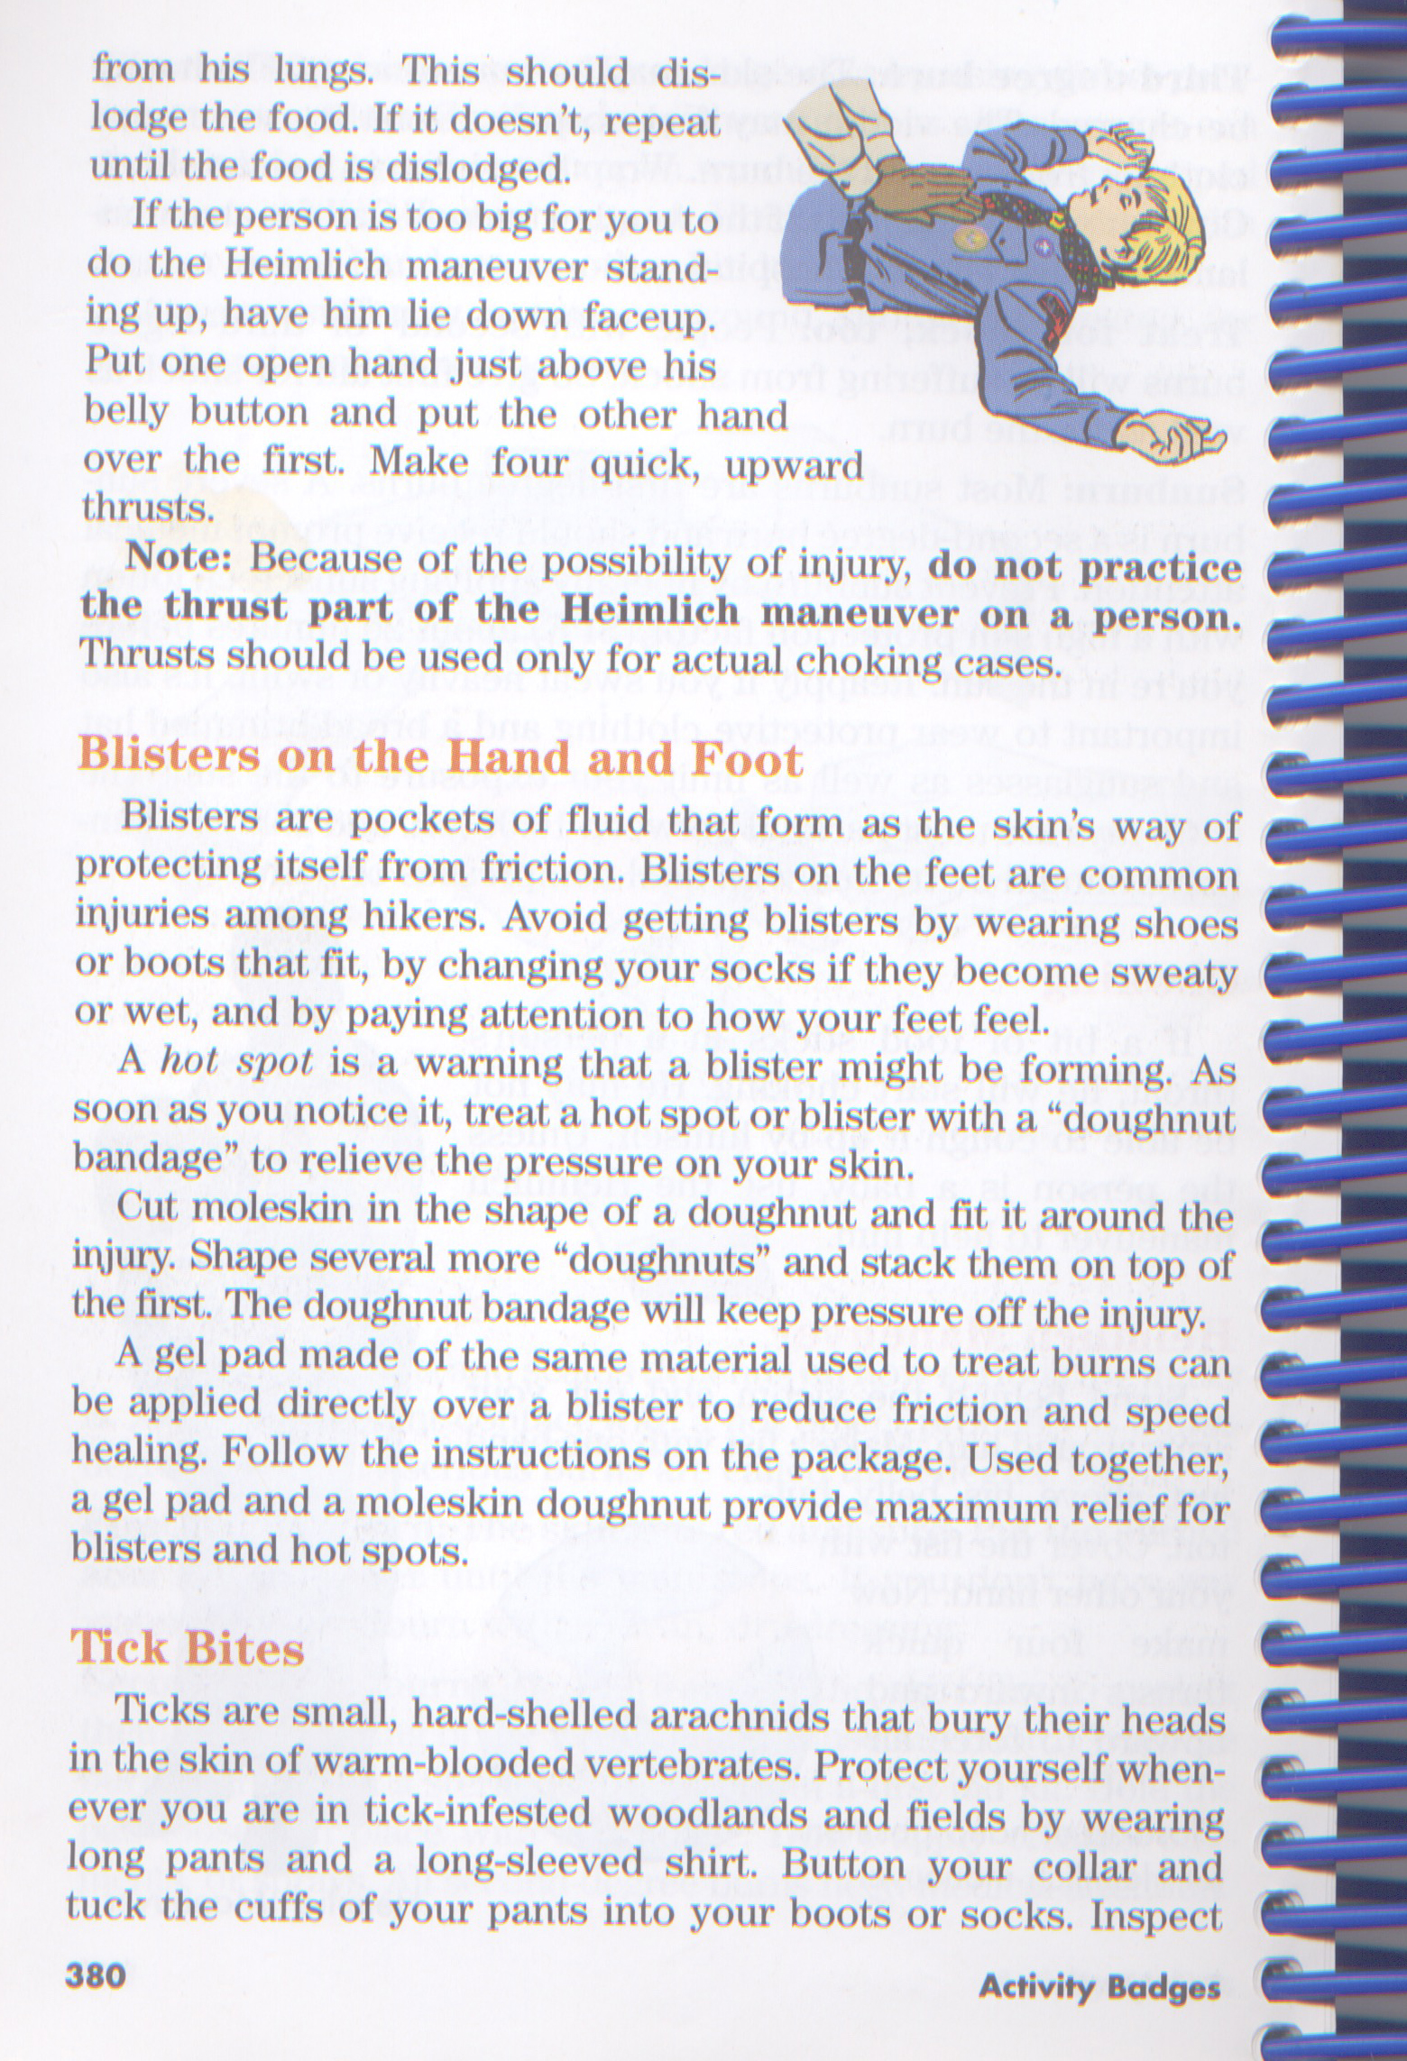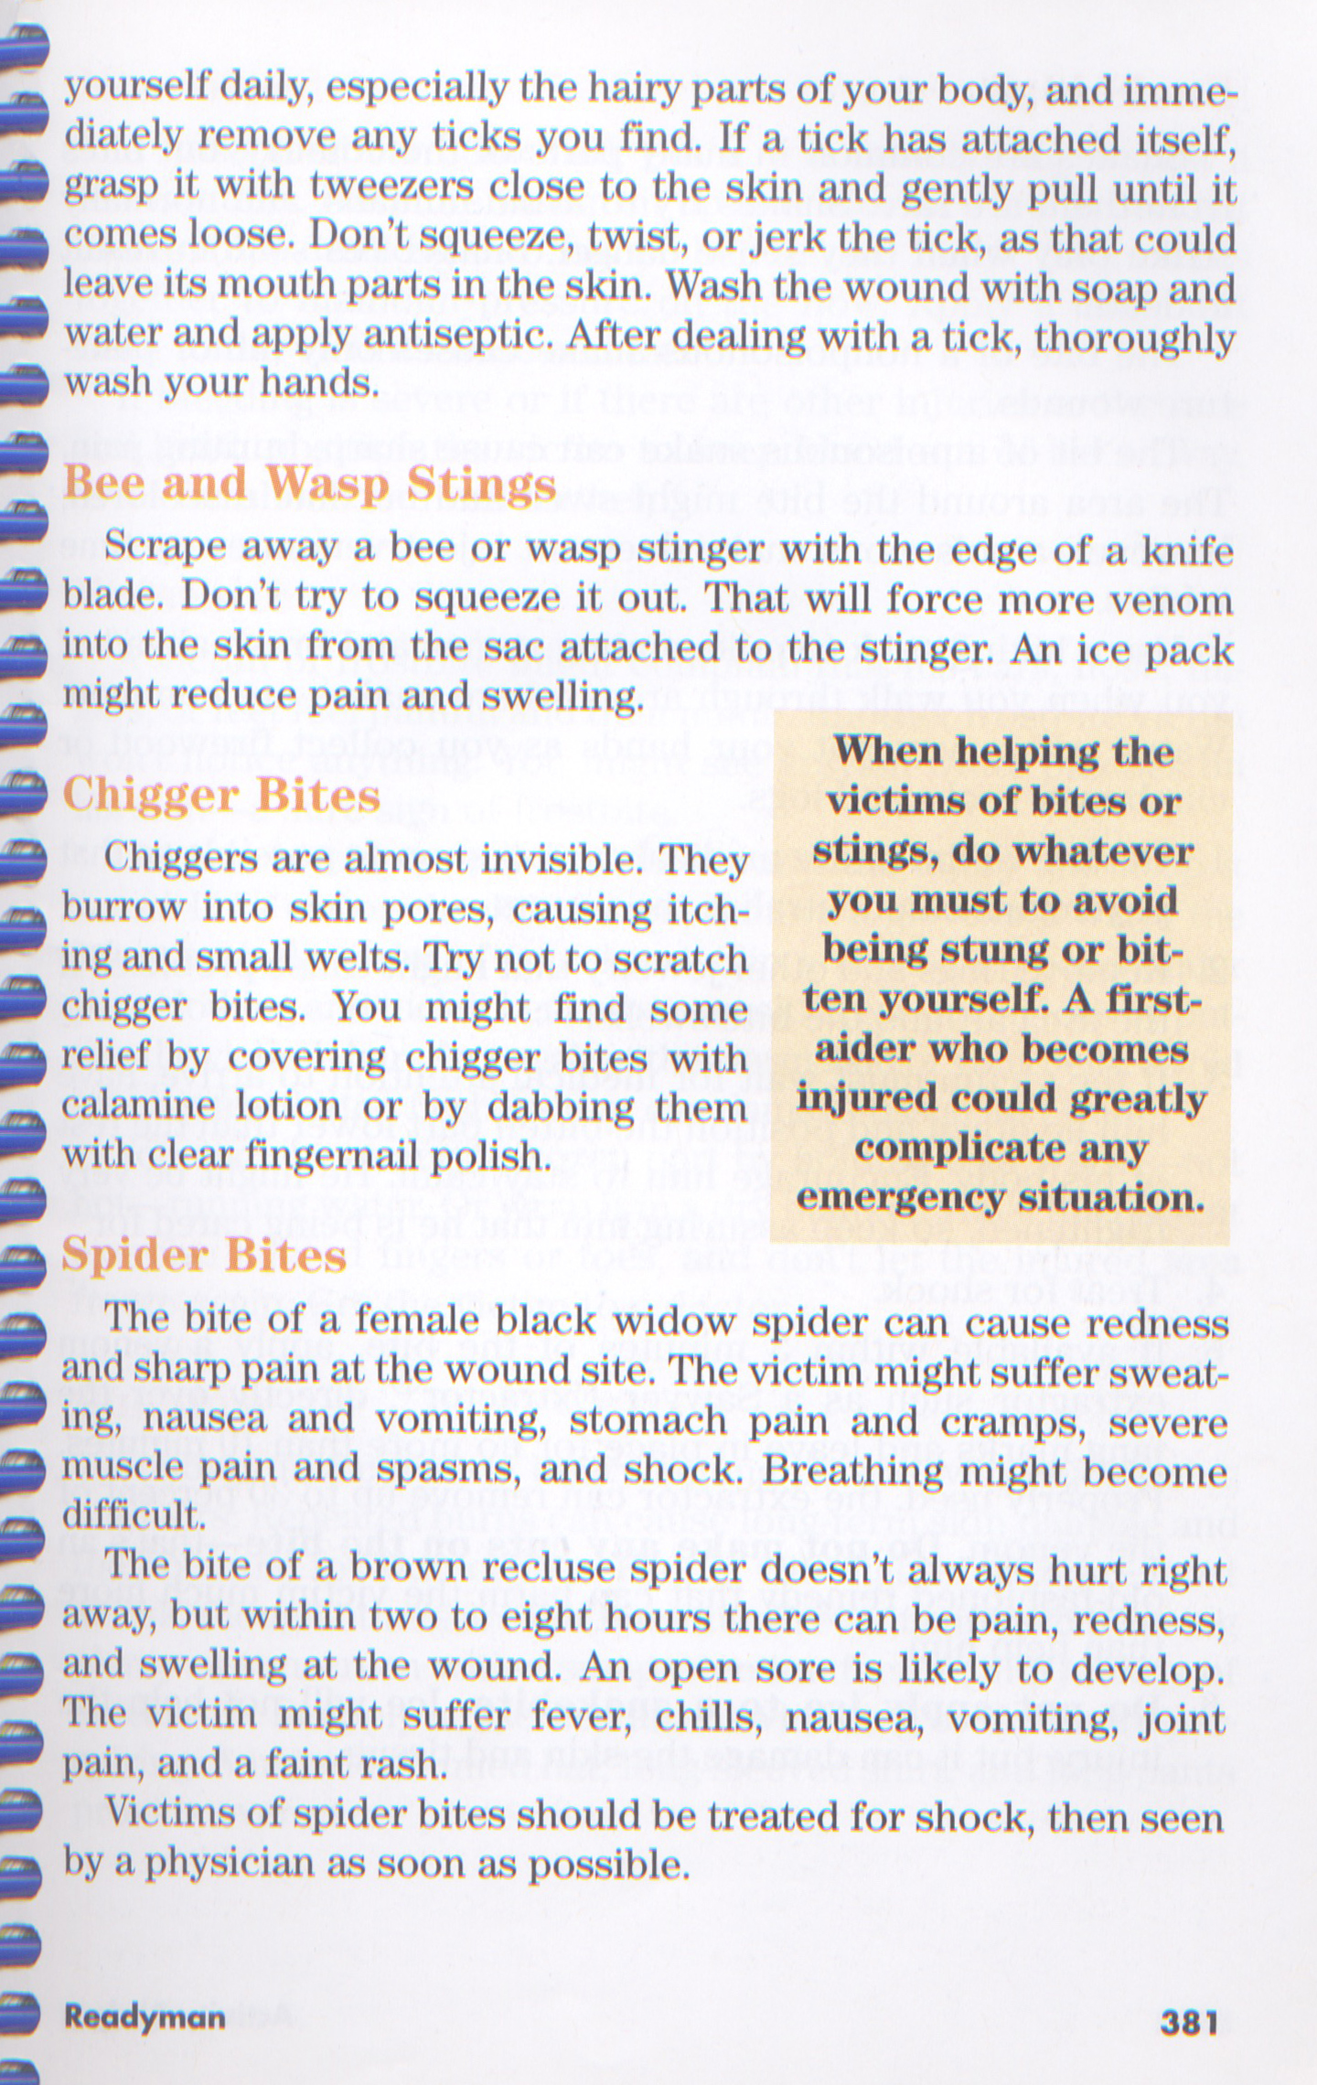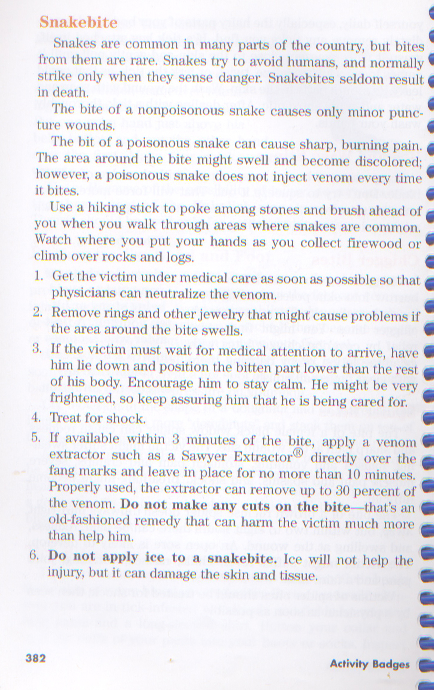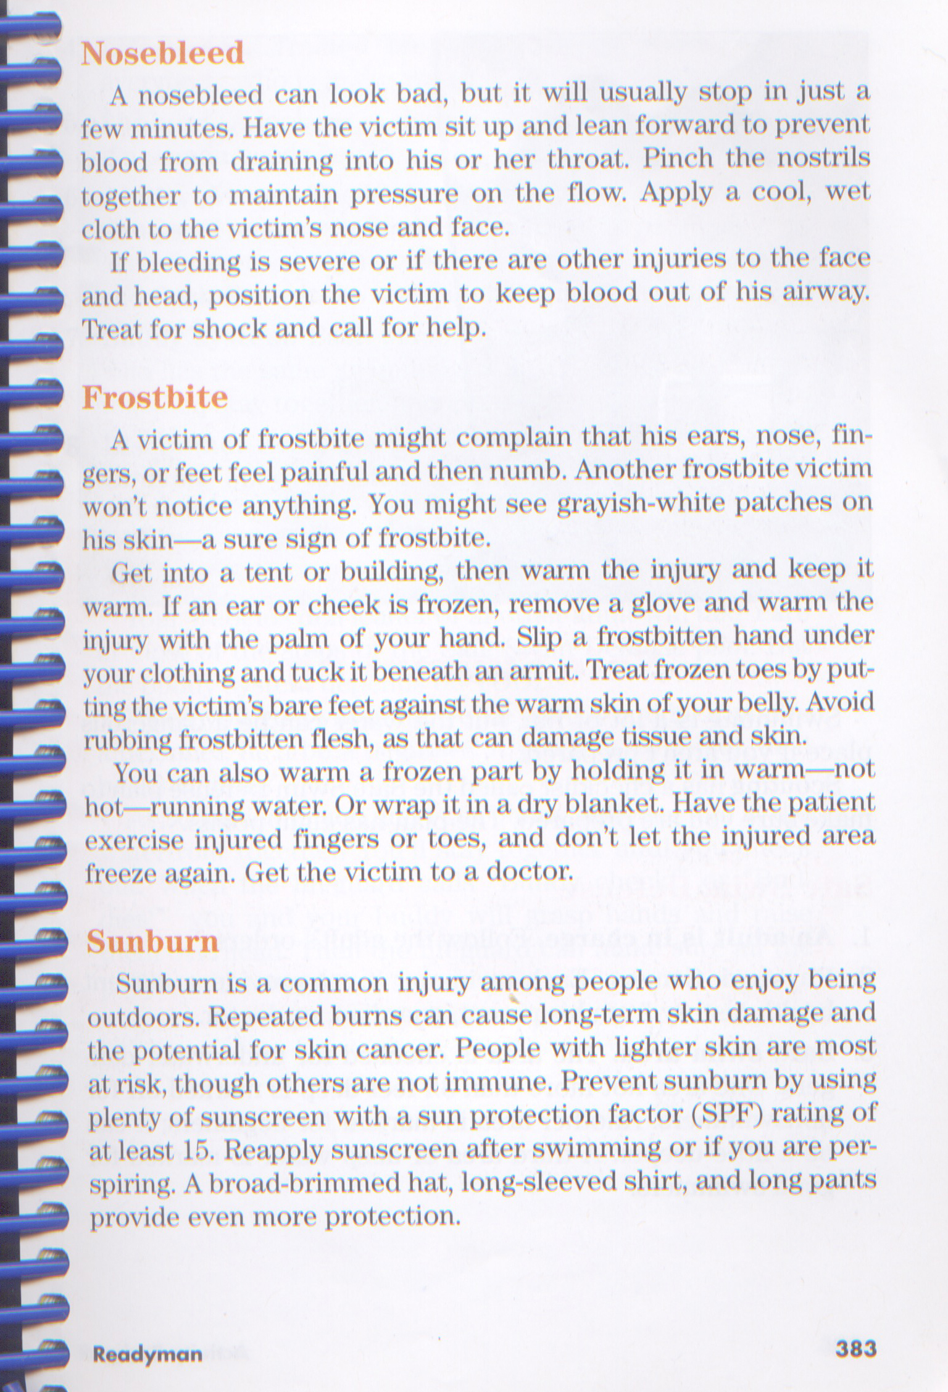
Site 2: First Aid - (Moulage) - Req 7
- Cuts
- Scratches
- Burns (first degree, 2nd degree, 3rd degree)
- Blisters

Scouts:
Noah (team lead)
Aaron
Ryan
Dave S.
Dave G.
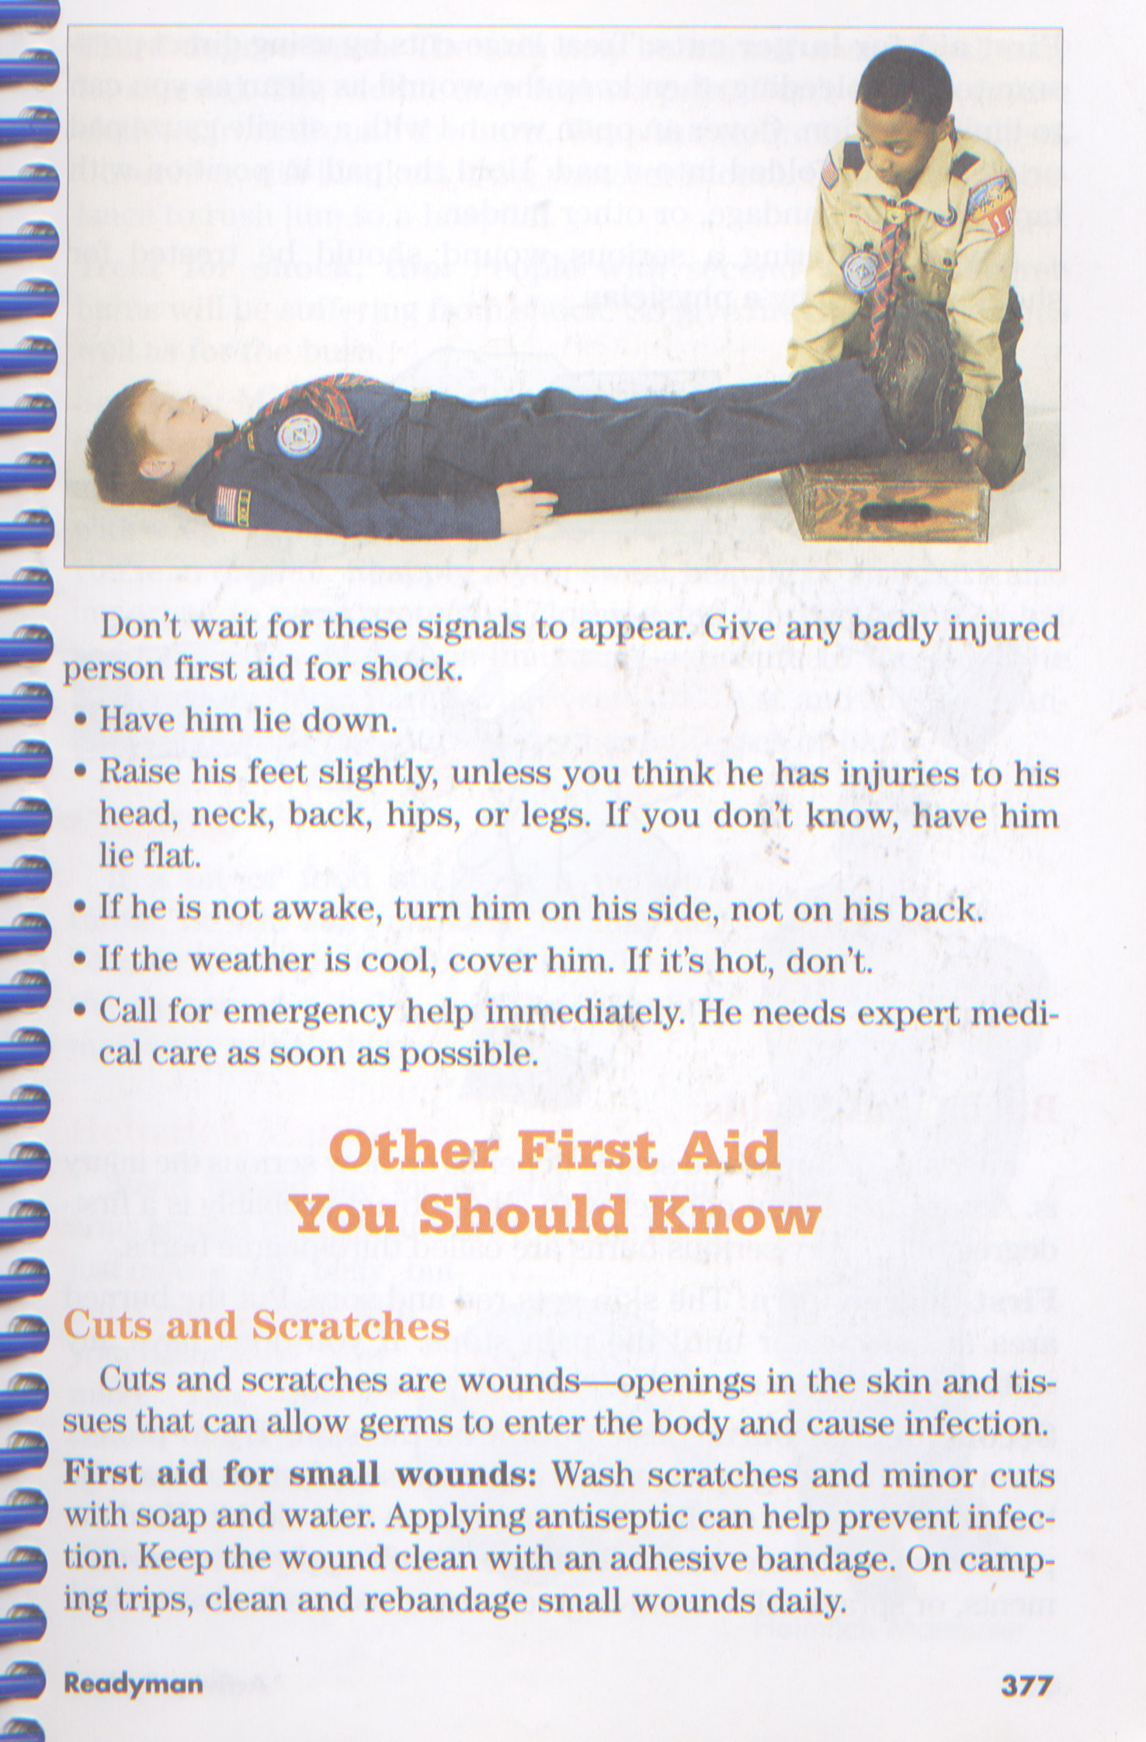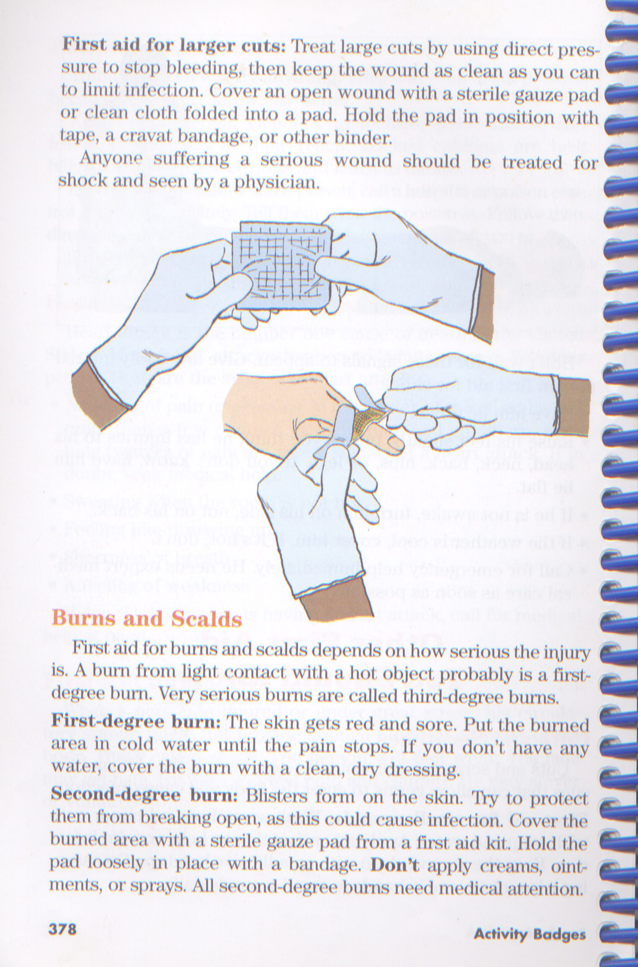
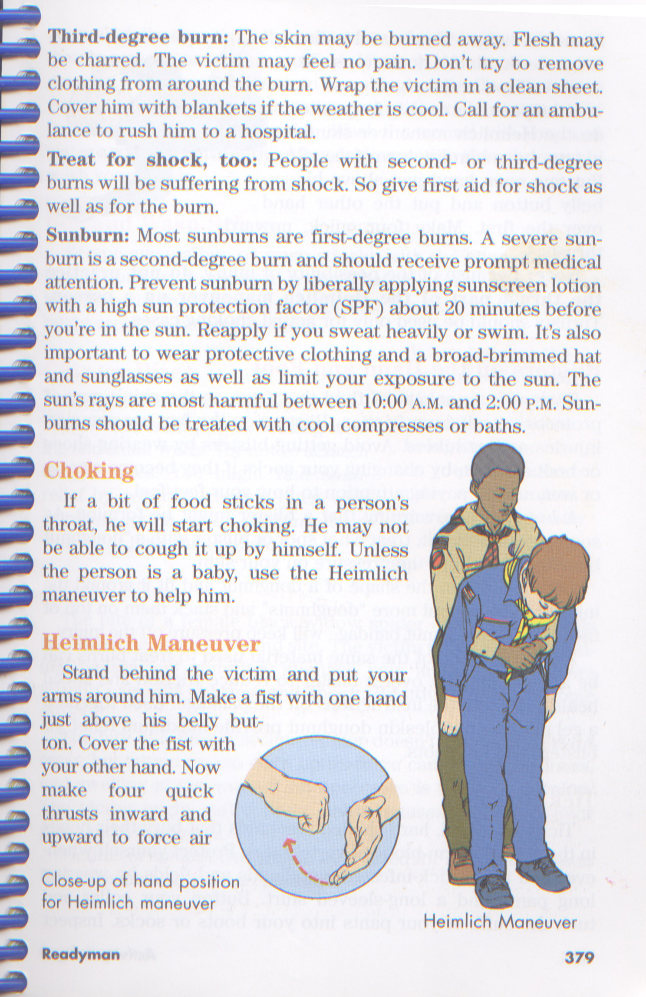
Site 3: Hurry Cases – Req 5 & 6
- Bleeding
- Stopped breathing
- Poison
- Heart Attach
- Treating Shock

Scouts:
Alex S. (team lead)
Ethan D.
Dan C.
Sam
Rahul
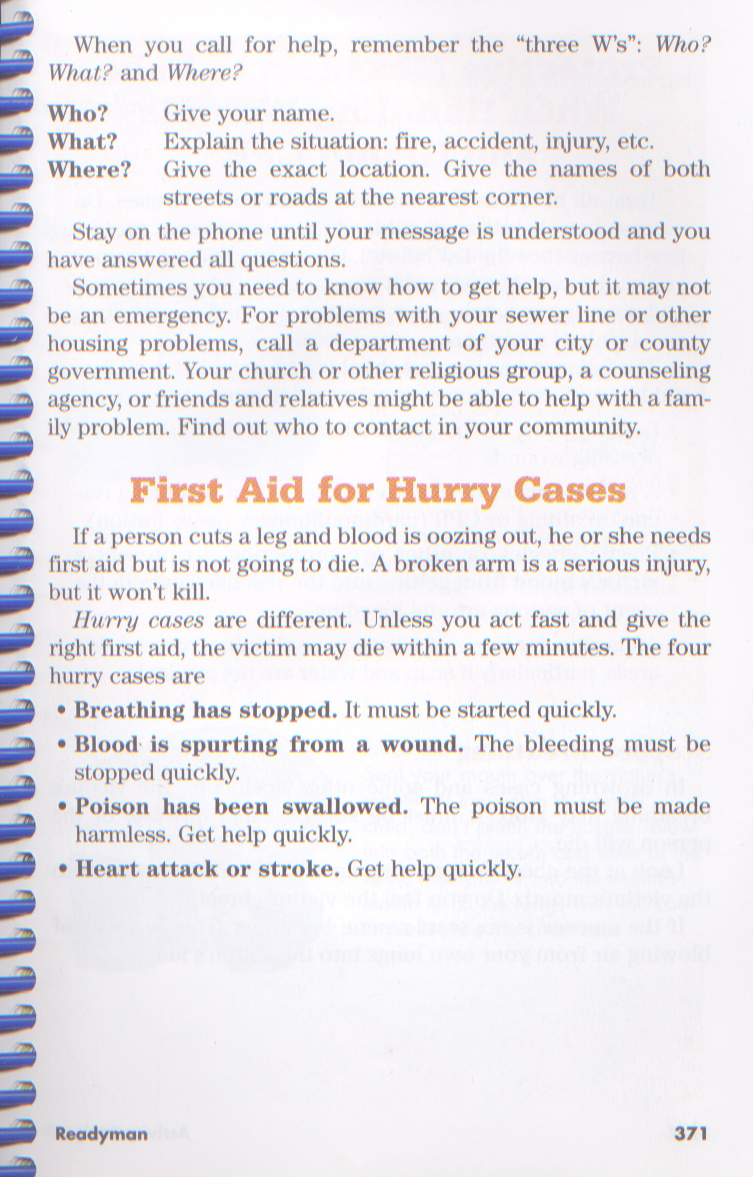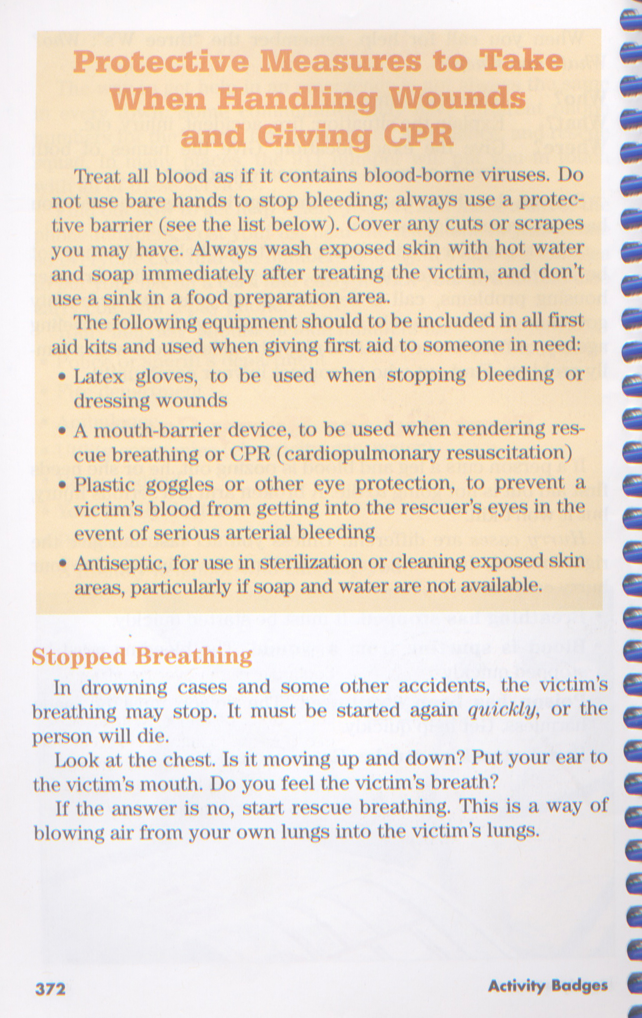
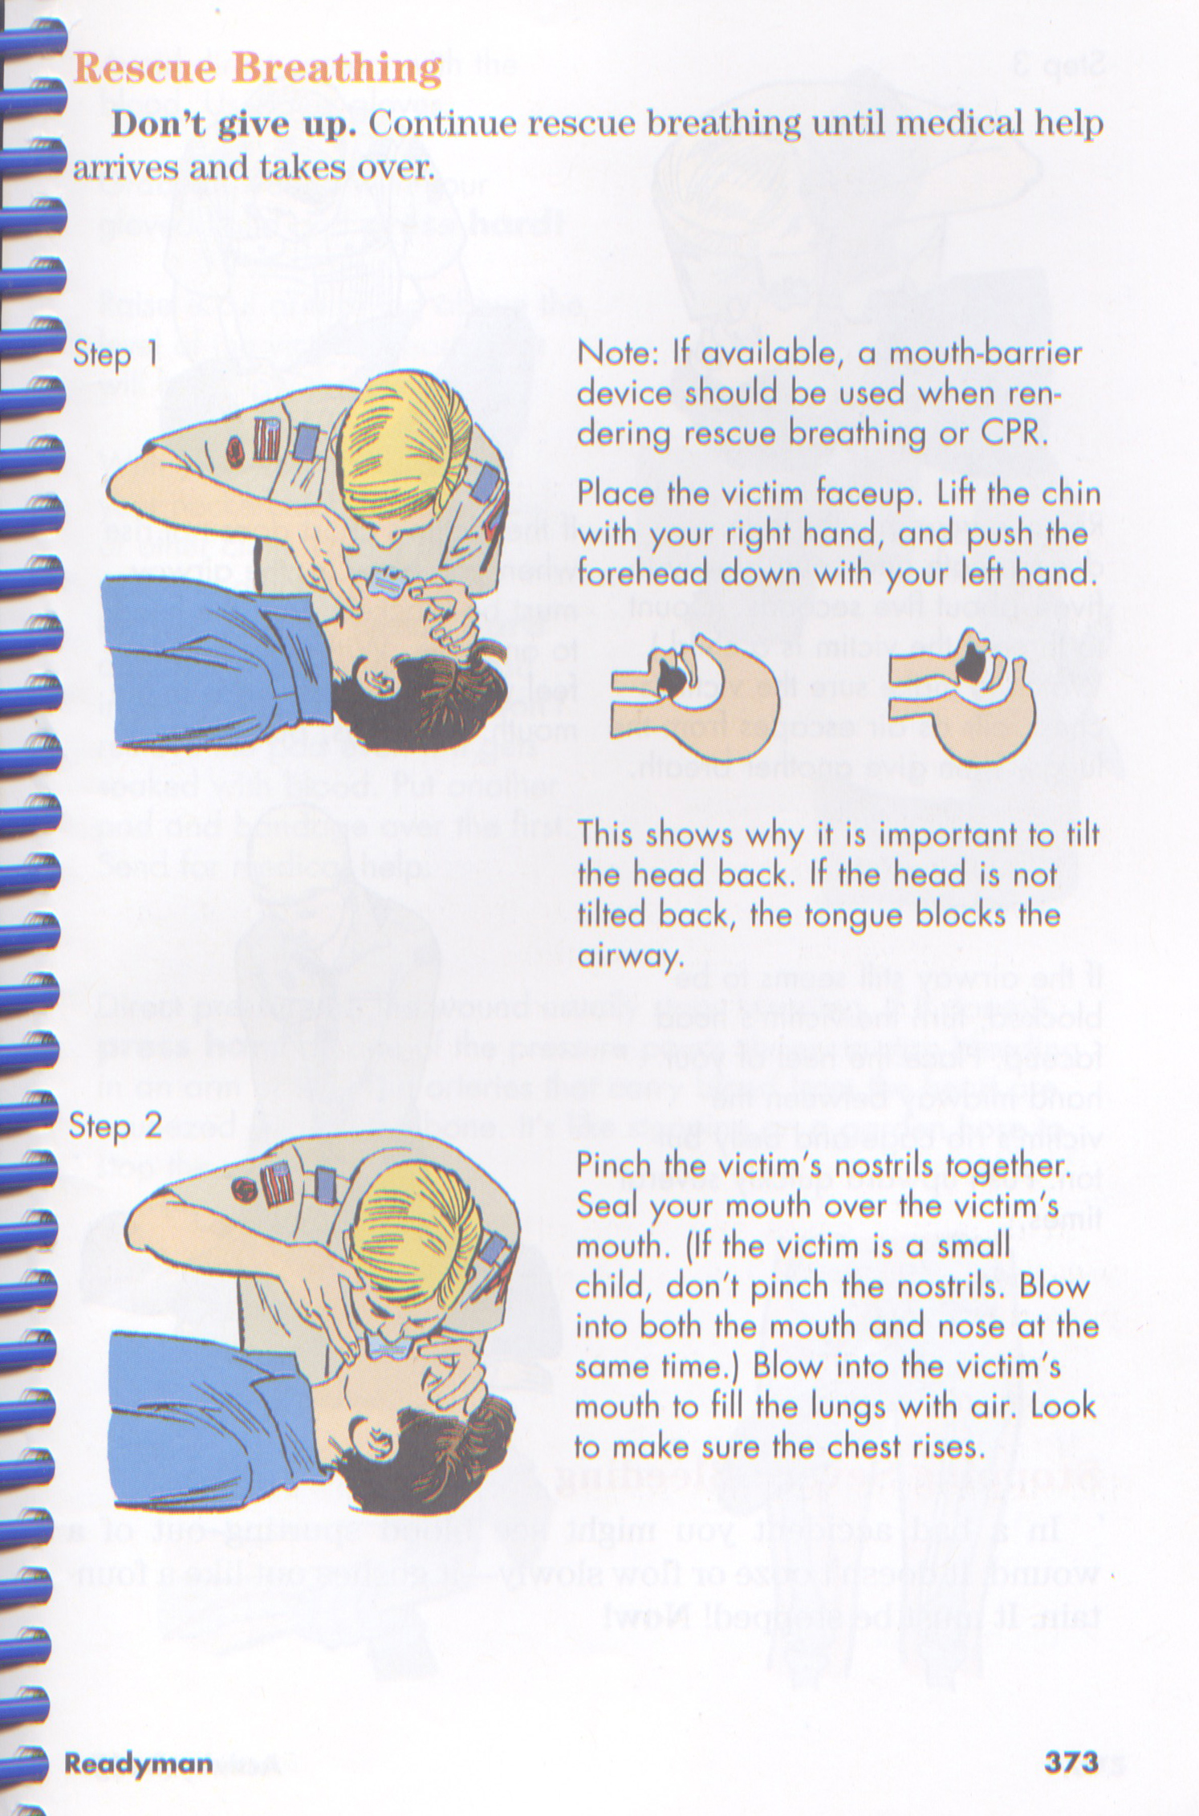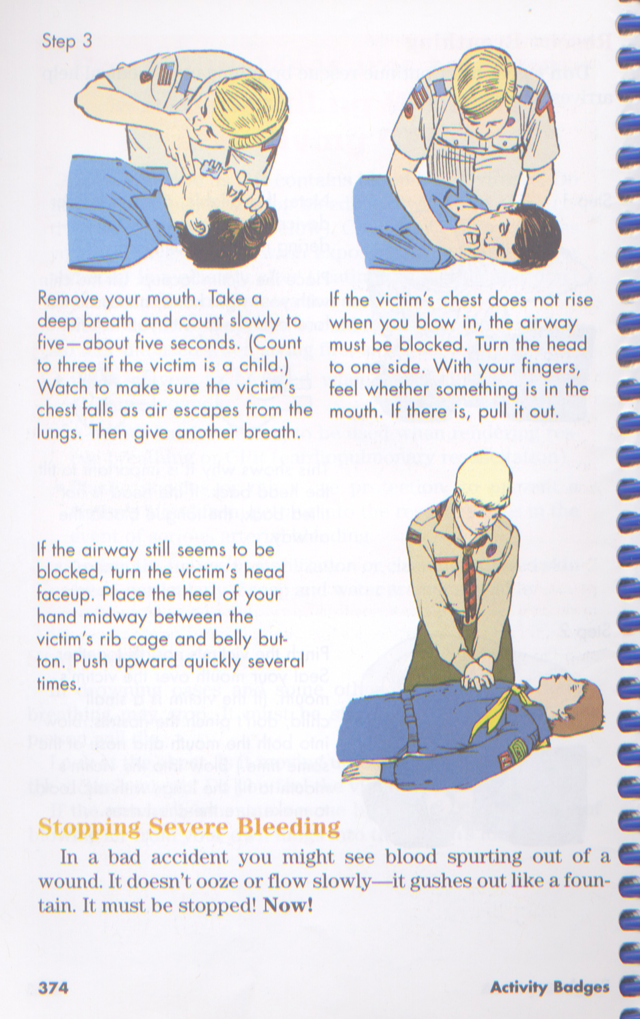
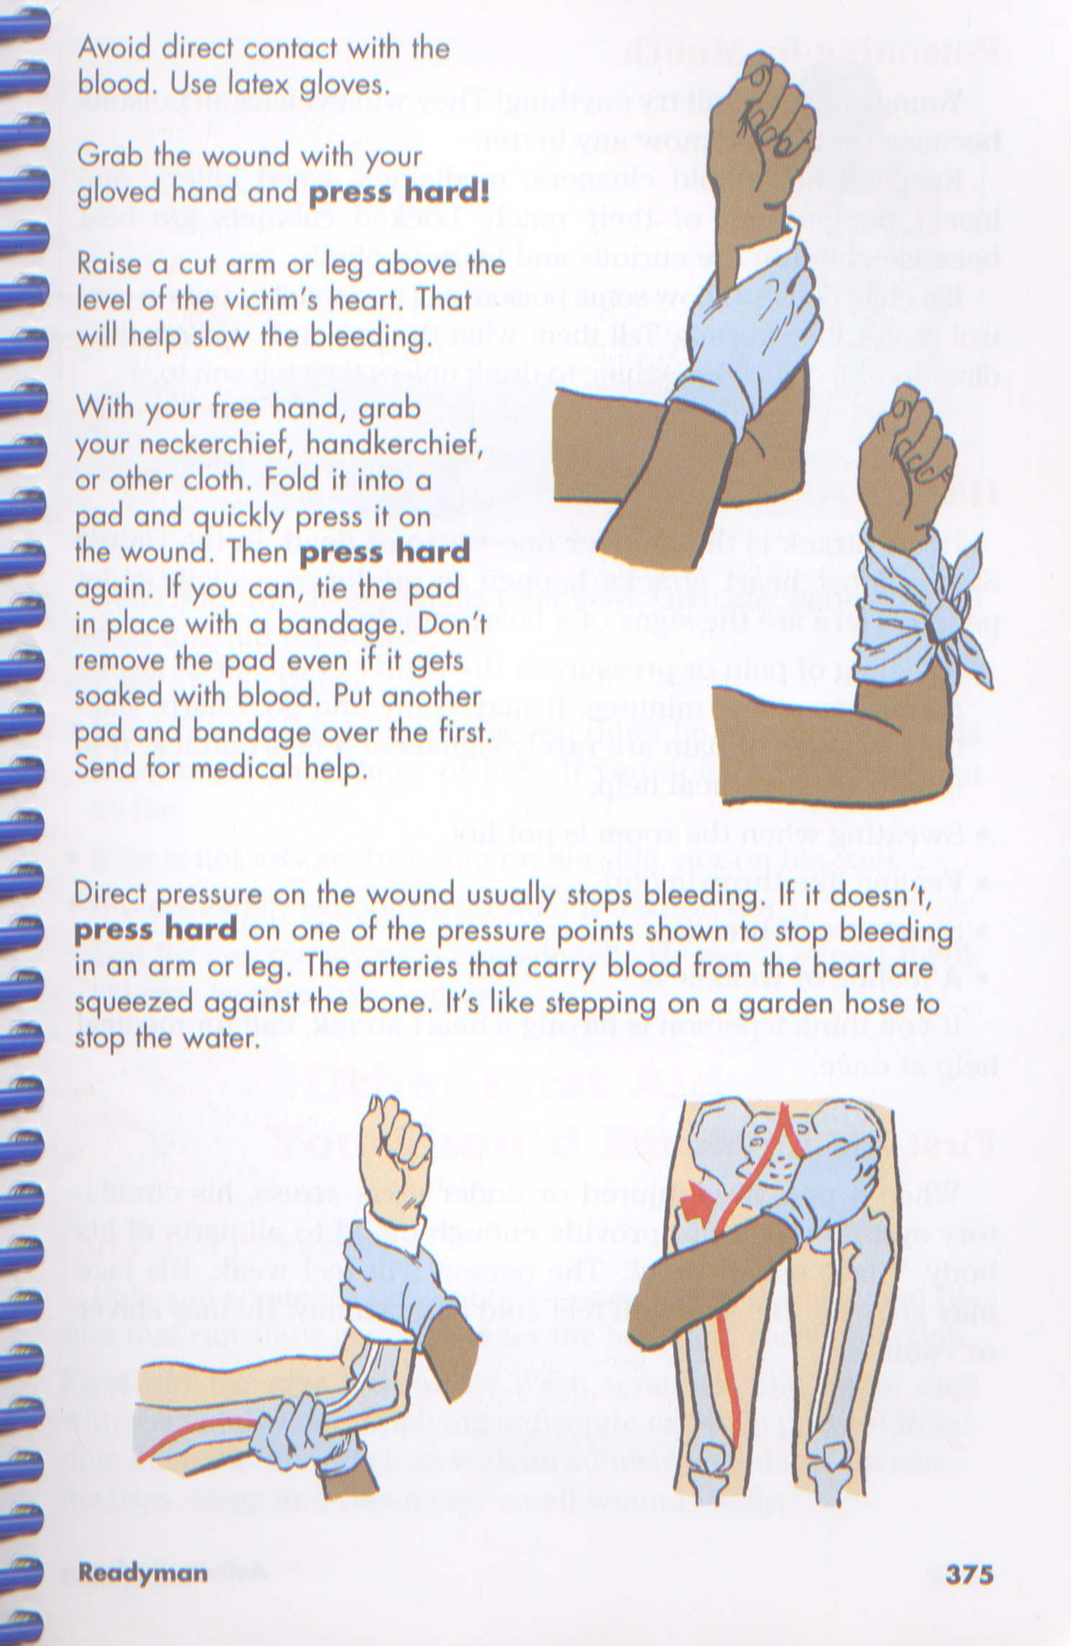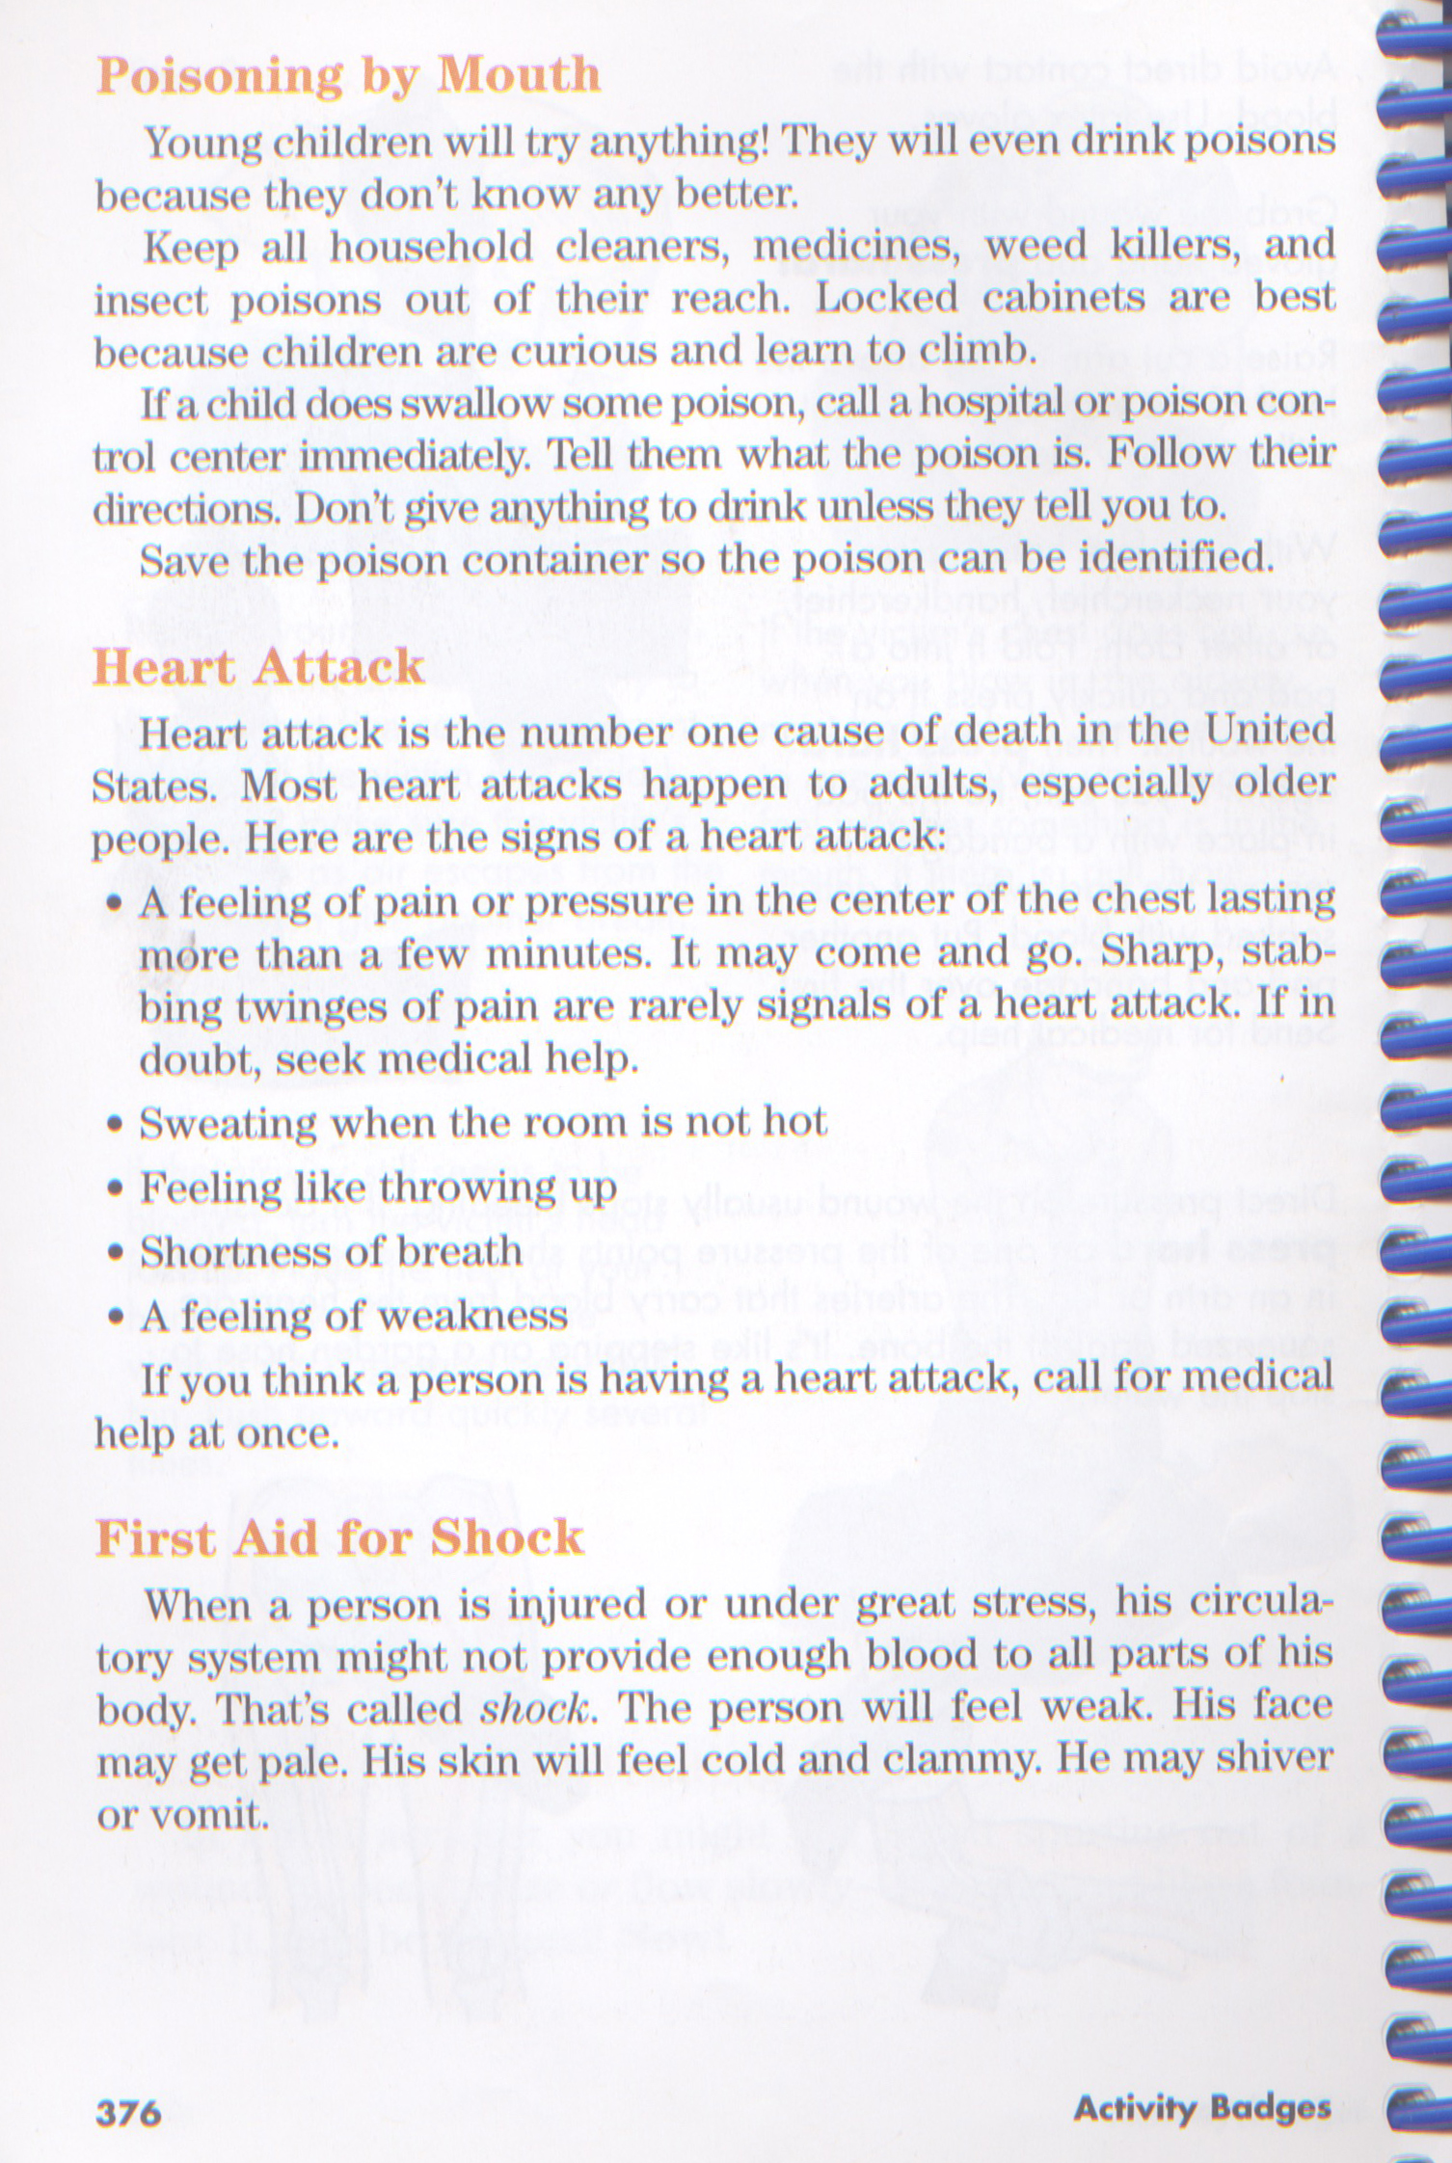
Site 4: Heimlich Maneuver & Buddy System – Req 4, 7 & 8
- Heimlich Maneuver
- First Aid for Choking
- Explain Buddy System
- Steps for Safe Swim

Scouts:
Jungmin (team lead)
Ian
Jared
Alex L.
Mike F.
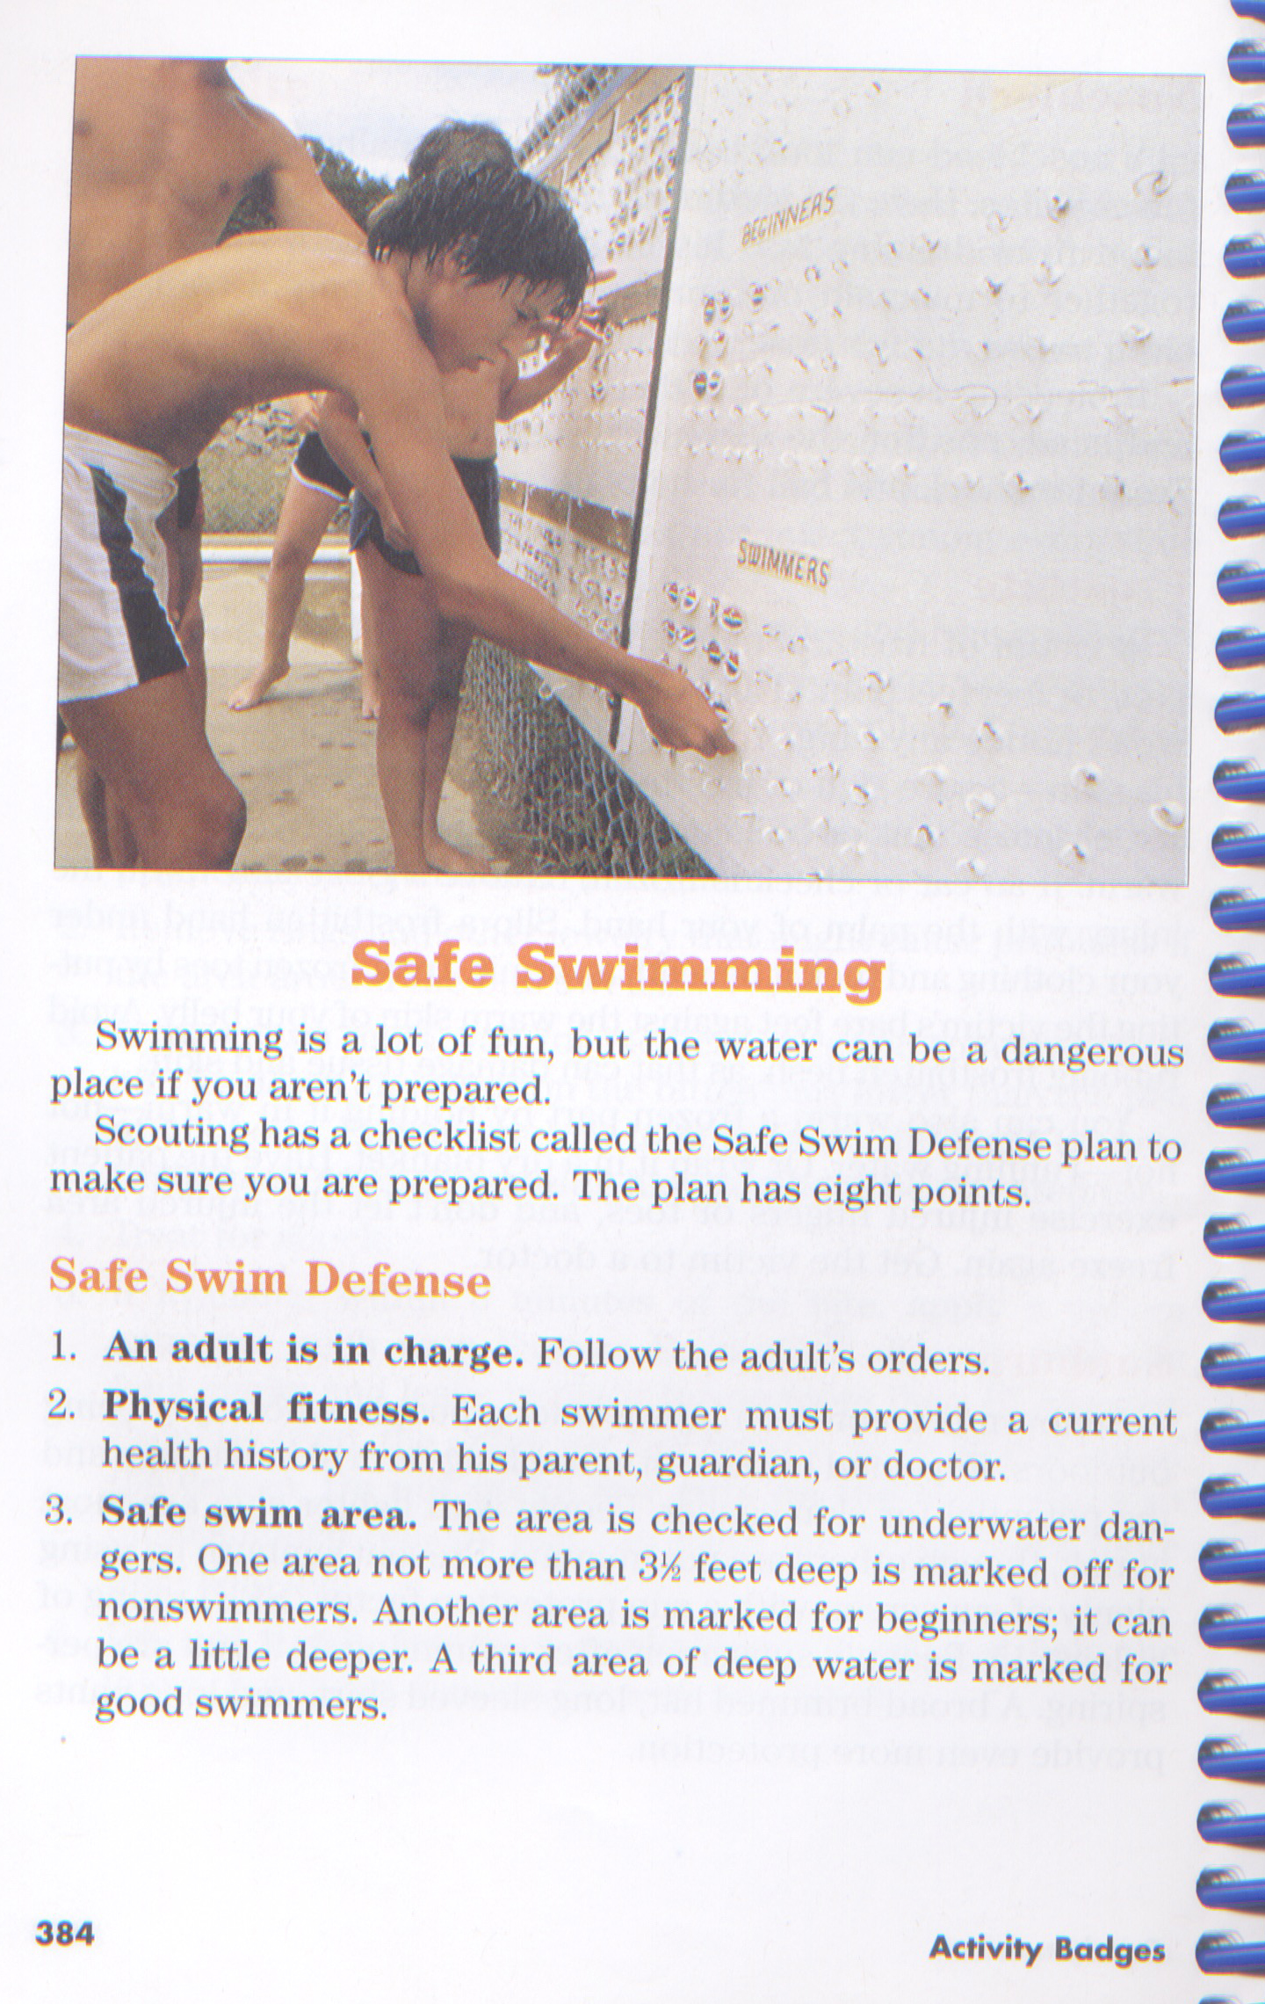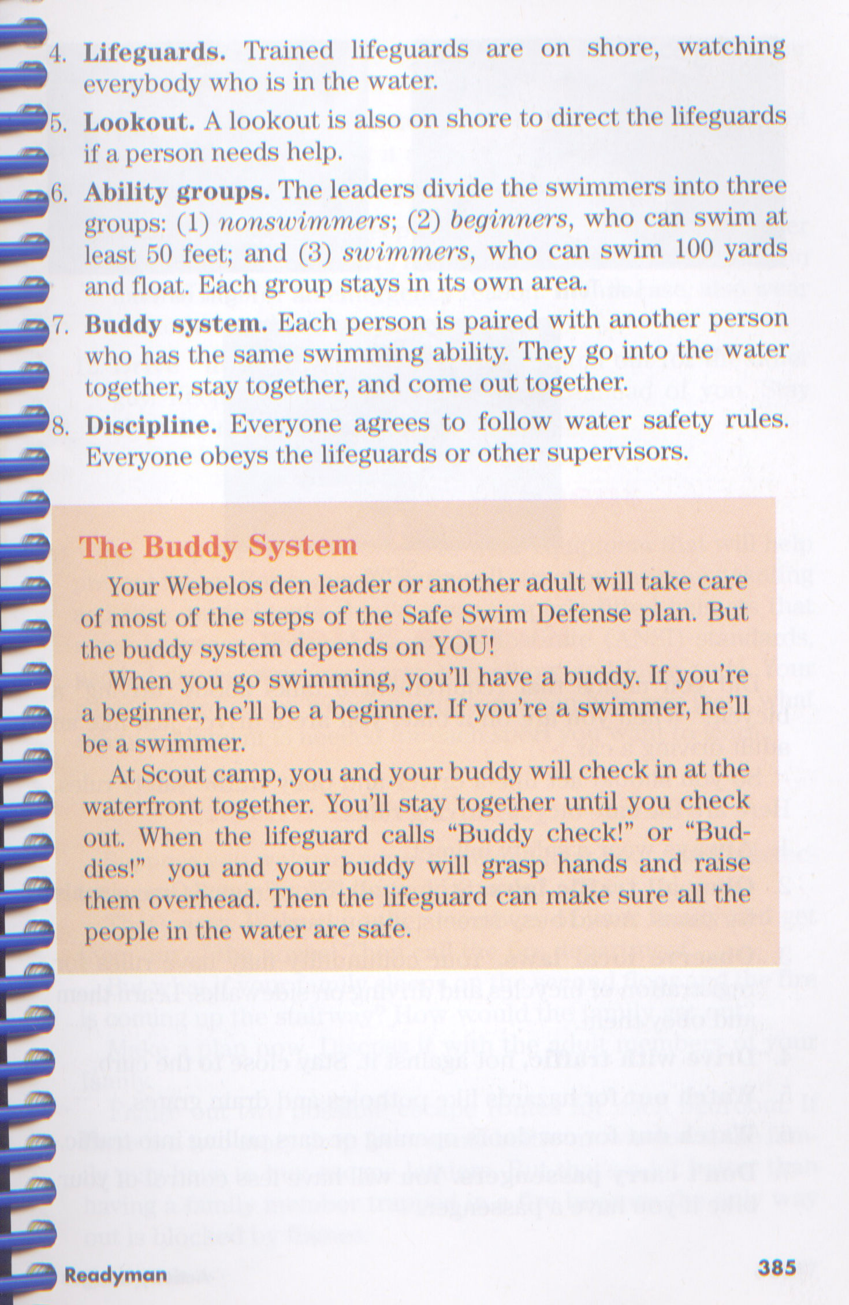
Site 5: First Aid & Help List – Req 2, 3 & 12
- Explain First Aid Kit
- Discuss what is first aid
- What to do after an accident
- Make a help list

Scouts:
Mike Synnott (Team Lead)
Dan R.
Robert Chasen
Anthony
Evan
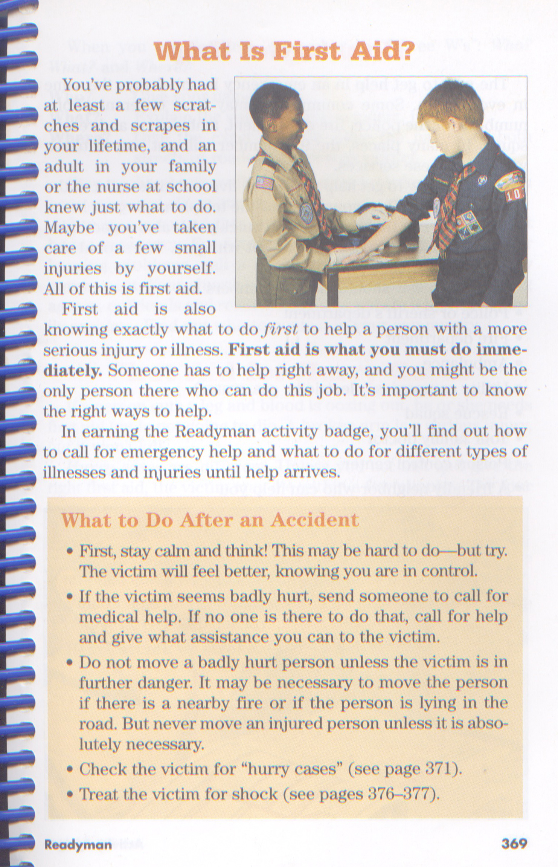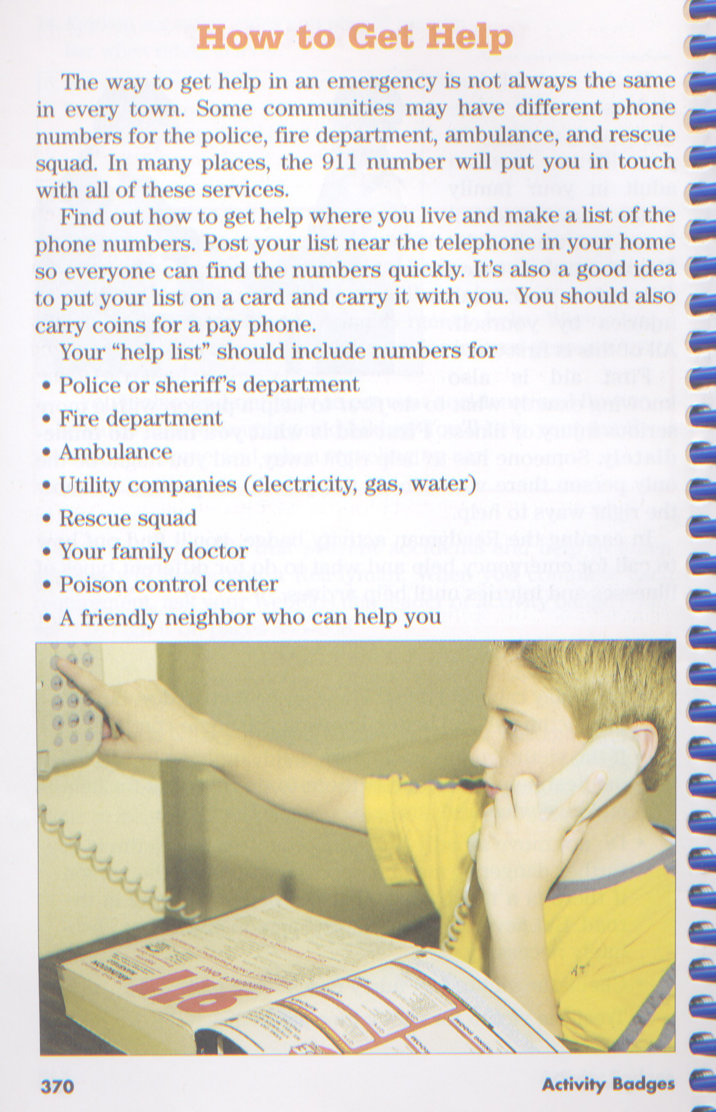
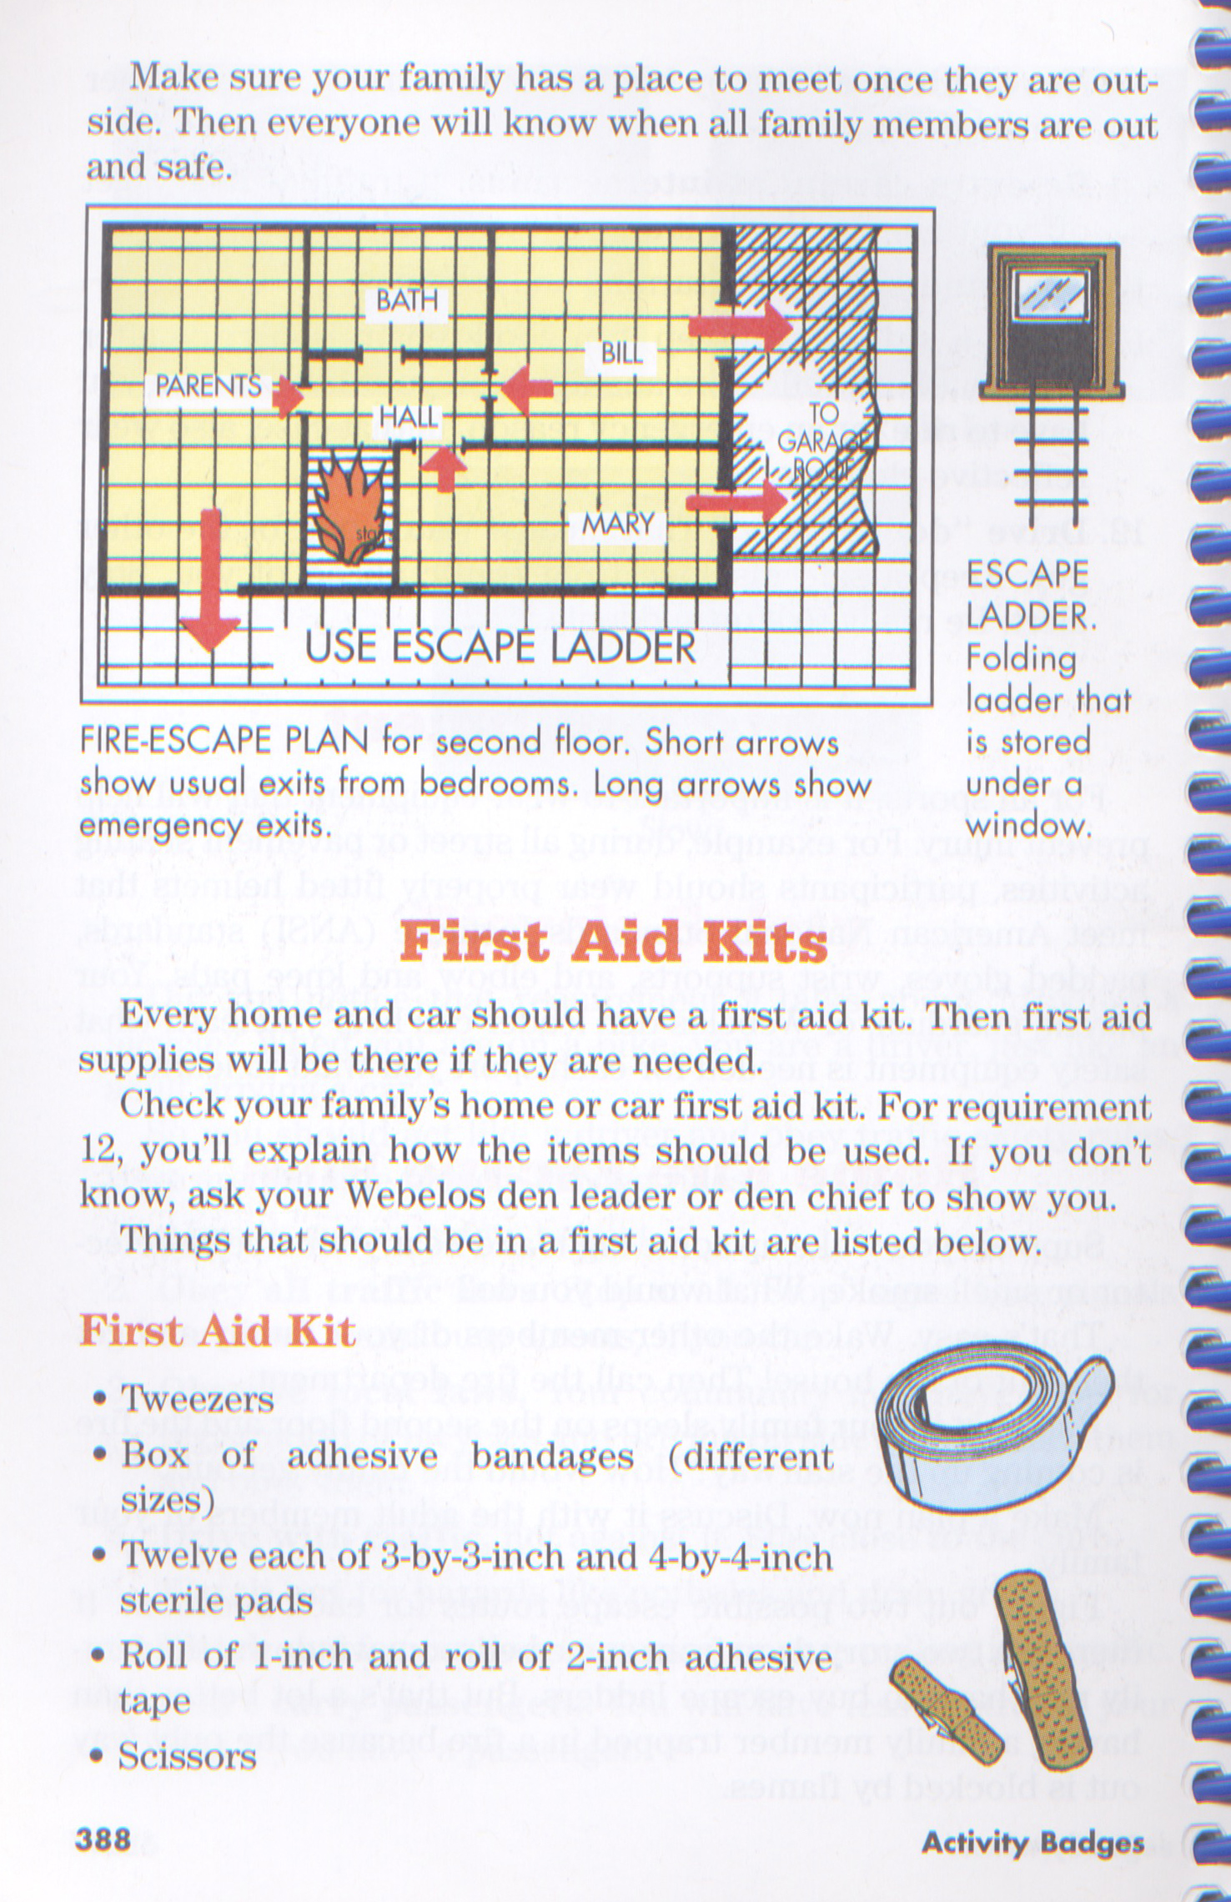
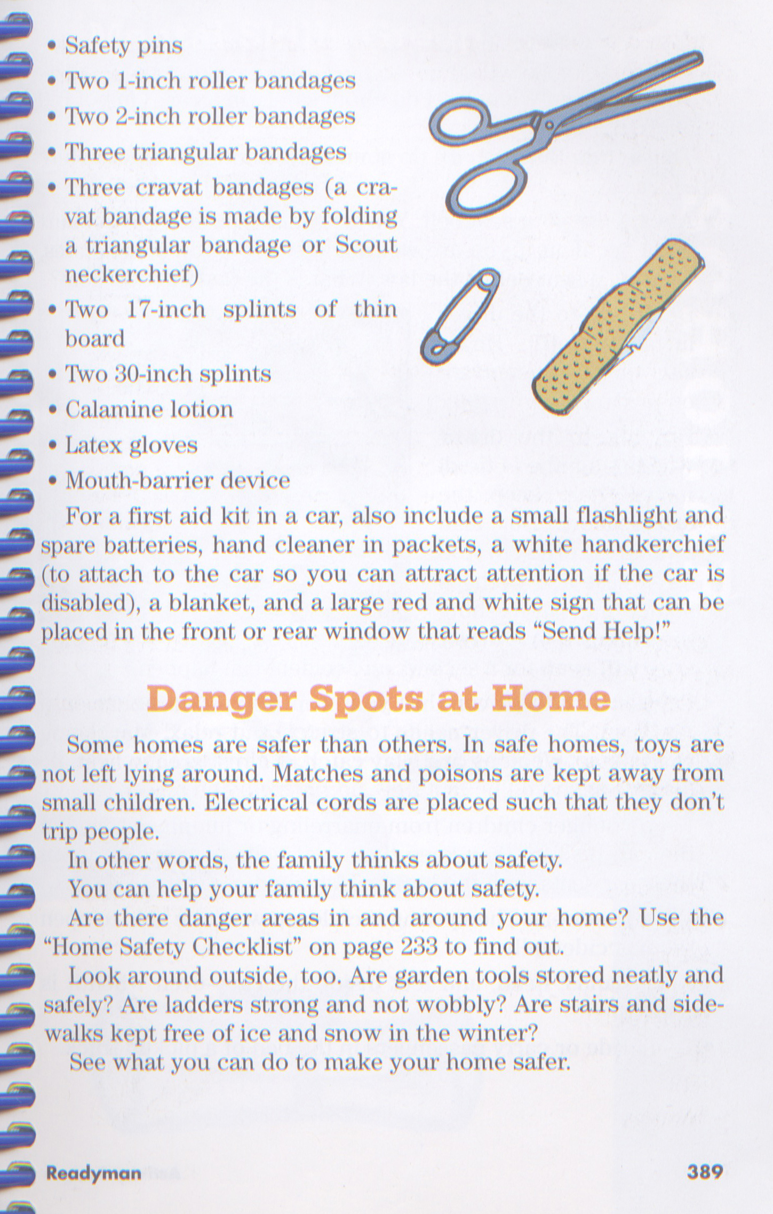

Greeters

Scouts:
Luke
Zack
Thomas
Kevin

