Chicken and Dumplings

|  |  |  |
| --- | --- | --- |
| I**NGREDIENTS** | Shopping List (for 6) | Cost |
| 4-5 chicken breasts, skinless boneless | 4-5 chicken breasts | 7.00 |
| 3 15-ounce cans chicken broth | Knorr Bouillon Chicken Flavor | 5.00 |
| 3 medium potatoes, diced | Fresh Potatoes Yukon Yellow - 5lb | 4.00 |
| 2 small onions, diced | Bag of Onions | 4.00 |
| 10 baby carrots, sliced | ShopRite Baby Carrot bag | 4.00 |
| 1 can of peas | 15oz cans of peas | 2.00 |
| 1/2 teaspoon garlic salt | (in cabinet) |  |
| 1 teaspoon thyme | (in cabinet) |  |
| 1 teaspoon salt | (in cabinet) |  |
| 1/2 teaspoon black pepper | (in cabinet) |  |
| 2 bay leaves | (home) |  |
| 4 tablespoons flour | (home) |  |
| 2 cans of refrigerator biscuits | Pillsbury Biscuits - 4pack | 4.00 |
| 2 tablespoons vegetable oil | (in cabinet) |  |
| 2 tablespoons butter | (home) |  |
| Total | ($5 per person) | $30.00 |

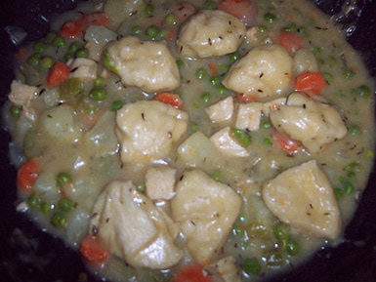

At home:

* Sauté Chicken breasts and cut into 1-inch chunks
* Sauté onions, let cool and pack separately
* Pack small container of flour
* Prepare spice bag with ½ teaspoon garlic salt, 1-teaspoon thyme, 1-tsp salt, ½ teaspoon pepper, 2 bay leaves.

At Campsite:

Use a cast-iron Dutch oven, a stove top Dutch oven, or a large pot with a lid. Add oil to pot and heat to medium.

Saute the chicken breasts for about 20 minutes, turning after 10 minutes. Remove chicken to a cutting board.

Add butter to pot. Add onions, flour and stir to moisten and make a rue.

Add one can of broth and stir until the gravy is smooth.

Add remaining vegetables, diced chicken, spices and 2nd can of broth. Stir well, bring to a boil and then reduce to a simmer.

Take biscuits, and place them on top of the stew. Put a lid on the pot and simmer for about 10 minutes.

Remove the bay leaves before serving.

Servings: 6Spinach-Artichoke Cheesy Tortellini

|  |  |  |
| --- | --- | --- |
| I**NGREDIENTS** | Shopping List (for 6) | Cost |
| 1 (10 oz) box frozen spinach, thawed/drained | 1 (10 oz) box frozen spinach | 2.00 |
| 2 tablespoons olive oil | (in cabinet) |  |
| 1 tablespoon butter | (at home) |  |
| 3 garlic cloves, chopped | (at home) |  |
| 1 small onion, grated | Bag of Onions | 4.00 |
| 2 tablespoons flour | (at home) |  |
| 1 cup chicken broth | Knorr Bouillon Chicken Flavor | 4.00 |
| 1 cup heavy cream | Shopite Heavy Cream 8 oz | 2.00 |
| 1⁄8 teaspoon nutmeg | (at home) |  |
| 1 (14 ounce) can water-packed artichoke hearts, drained and chopped | Cento Artichoke Hearts 1 can | 3.00 |
| 1 cup grated parmesan cheese | ShopRite Parmesan Cheese-Grated 8oz | 3.00 |
| 1 lb cheese tortellini | 2 bags ShopRite Cheese Tortellini | 6.00 |
| 2 tablespoons butter | (home) |  |
| Total | ($4 per person) | $24.00 |

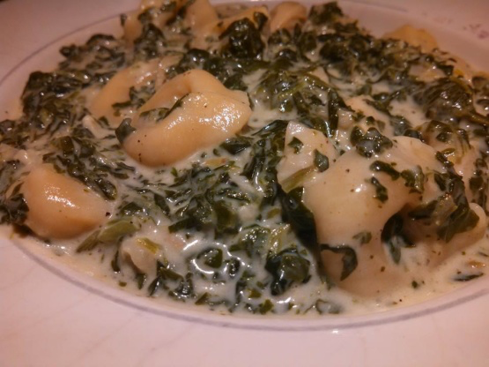

At home:

* Pre-cook tortellini
* Cut up onion and add garlic
* Pack small container of flour

At Campsite:

Heat a deep skillet over medium heat with the oil and butter.

When butter melts, add garlic and grated onion. Saute for 5 minutes.

Sprinkle the flour into the skillet and cook for 1 minute.

Whisk in the broth, then the cream and bring to a bubble.

Season the sauce with nutmeg and reduce heat to low. Separate spinach into pieces as you add it to the sauce.

Stir in the artichokes and cheese and season to taste with salt and pepper. Add tortellini with the spinach artichoke sauce.

Serve immediately with additional grated cheese.

Servings: 6

Dutch Oven Mountain Man Breakfast

|  |  |  |
| --- | --- | --- |
| I**NGREDIENTS** | Shopping List (for 6) | Cost |
| Banquet Brown & Serve Original Links | 1 pkg. Banquet Brown & Serve Links | 2.00 |
| 1 onion, chopped | Bag of onions | 4.00 |
| 1 green bell pepper | 1 green bell pepper | 2.00 |
| 1 (2lb) pkg frozen shredded hash browns | ShopRite Hash Brown Potatoes (32 oz) | 3.00 |
| 12 eggs, beaten | ShopRite Large Eggs (18 ct) | 4.00 |
|  | ShopRite Sharp Cheddar - Shredded | 3.00 |
| Total | ($3 per person) | $18.00 |

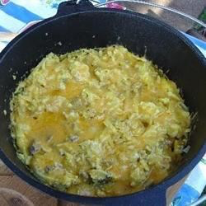

Cook and stir the sausage and onion, in a 12-inch cast iron Dutch oven with lid, raised over the coals to medium-high heat, until the onion is tender.

Stir in the red bell pepper, green bell pepper, and hash brown potatoes until evenly mixed. Cook, stirring occasionally, until the hash browns are hot and the peppers are tender, about 15 minutes.

Pour the beaten eggs evenly over the top of the potatoes, allowing them to sink into the potatoes.

Cover the Dutch oven, and place 9 coals underneath and 12 to 18 on top will give you approximately 350 degrees.

Allow to bake until the eggs are firm, about 40 minutes. Sprinkle with Cheddar cheese, cover, and continue cooking until the cheese has melted, about 5 minutes.

Servings: 6

Skillet Chicken Lasagna

|  |  |  |
| --- | --- | --- |
| I**NGREDIENTS** | Shopping List (for 6) | Cost |
| Bow tie pasta | 1 box Bow tie pasta | 2.00 |
| 2 tablespoons olive oil | (in cabinet) |  |
| Salt |  |  |
| 2 boneless chicken breasts (diced) | 1 package of 2 chicken breasts | 4.00 |
| 1 tablespoon Italian seasoning | (at home) |  |
| 1 medium onion (diced) | Bag of onions | 4.00 |
| 2 cloves garlic (minced) | 1 ball of garlic | 2.00 |
| 1 teaspoon red pepper flakes | (at home) |  |
| 1 jar marinara sauce | Colonna Marinara Pasta Sauce | 2.00 |
| 1 cup grated mozzarella cheese | ShopRite Shredded Mozzarella | 2.00 |
| 1/2 cup whole milk ricotta cheese | ShopRite Whole Milk Ricotta Cheese | 3.00 |
| 1/4 cup grated Parmesan | ShopRite Parmesan Cheese – Grated 8oz | 3.00 |
| 1 cup low-sodium chicken broth | ShopRite Chicken Broth (32oz) | 2.00 |
| Basil 12 fresh leaves | (at home) |  |
| Total | ($4 per person) | $24.00 |

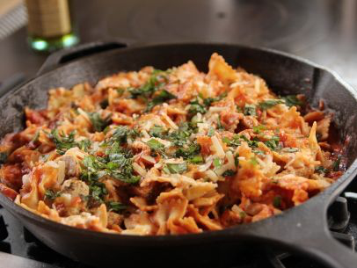Cook the pasta according to the package instructions; drain and set aside.

Heat the oil in a large skillet over medium-high heat. Season the chicken with the Italian seasoning and some salt. Add the chicken to the skillet and cook until golden brown, 2 to 3 minutes per side. Remove the chicken to a plate and set aside.

Add the onions and garlic to the same skillet and cook, stirring, for 3 minutes. Add the broth, then scrape the bottom of the skillet to loosen the bits. Cook for another 2 to 3 minutes to let the broth reduce. Add the marinara sauce and red pepper flakes, bring to a simmer and simmer for 10 minutes.

Turn off the heat and add the drained pasta, mozzarella, ricotta, Parmesan and basil. Add the cooked chicken on top. Toss to combine, then add more of the mozzarella, ricotta, Parmesan or basil until the sauce is just how you like it. Serve with a sprinkling of Parmesan and a little basil on top.

Servings: 6

Dutch Oven Salmon with Potatoes and Asparagus

|  |  |  |
| --- | --- | --- |
| I**NGREDIENTS** | Shopping List (for 4) | Cost |
| 6-8 Potatoes | 1 5lb bag red potatoes | 4.00 |
| 12 Asparagus | 1lb bunch Asparagus | 4.00 |
| Olive Oil | Olive oil | - |
| Lemon Pepper Spice | Lemon pepper spice | - |
| 2lb Salmon Fillet | 2lb Salmon Fillet | 20.00 |
| Parsley | 1 bunch parsley | 1.00 |
| 1 bundle green onions | 1 bunch green onions | 1.00 |
| Garlic | 1-2 cloves, minced | 1.00 |
| Dill | 1 pkg dill | 2.00 |
| 1 sliced lemon | 1 lemon | 1.00 |
| Total | ($9 per person) | $34.00 |

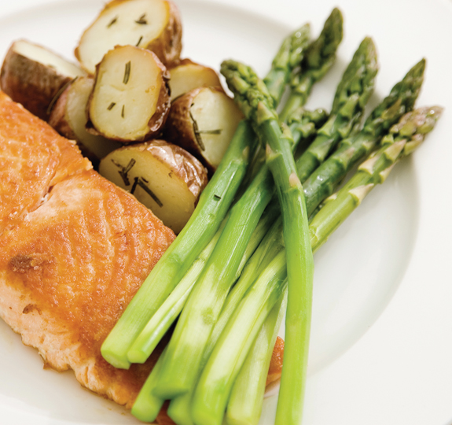In the dry-roasting phase: 25 + coals each above and below. In the final baking phase: 10-12 coals below, 18-20 coals above.

Heat up Dutch oven and season by putting olive oil on the cut up potatoes (6-8), parsley, salt, pepper, 1-2 cloves of minced garlic on bottom of Dutch oven

Let those cook for a while, using the dry-roasting technique, until they got good and seared on all sides, and the seasonings were clinging to potatoes (about 30 minutes).

Coat the asparagus with oil lemon salt and pepper. And put in Dutch oven for 5-10 min

Sprinkle dill, and chopped green onions, and put a lemon slice on each one salmon.

Add asparagus to potatoes and stirred them together. Lay salmon fillet pieces in on top. Replace lid and readjust coals as above, and began baking the salmon and asparagus with the potatoes. Cook for about 15-20 minutes or so.

Servings 4Dutch Oven Short Ribs & Polenta

|  |  |  |
| --- | --- | --- |
| I**NGREDIENTS** | Shopping List (for 4) | Cost |
| 8 whole Beef Short Ribs | 8 whole Beef Short Ribs | 13.00 |
| Kosher Salt and Pepper | Kosher Salt and Pepper | - |
| 1/4 cup All-purpose Flour | 1/4 cup All-purpose Flour | - |
| 6 pieces Pancetta, Diced | 6 pieces Pancetta | 5.00 |
| 2 Tablespoons Olive Oil | Olive Oil | - |
| 1 whole Medium Onion, Diced | 1 bag onions | 3.00 |
| 3 whole Carrots, Diced | 3 whole Carrots, Diced | 2.00 |
| 2 whole Shallots, Peeled And Finely Minced | 2 whole Shallots | 3.00 |
| 2 cups Red Wine | Goya Red Cooking Wine | 3.00 |
| 2 cups Beef Broth (To Almost Cover Ribs) | ShopRite Beef Broth | 2.00 |
| 2 sprigs Thyme | 2 sprigs Thyme | - |
| 2 sprigs Rosemary | 2 sprigs Rosemary | - |
| Polenta | 1 tube Food Merchants Polenta | 4.00 |
| Total | ($9 per person) | $35.00 |

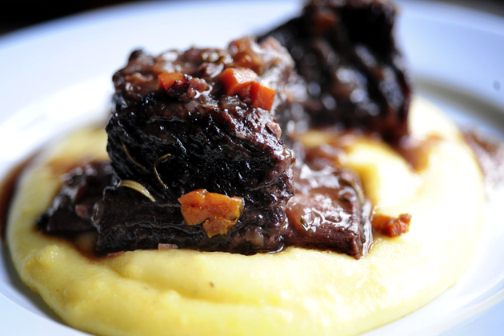

Salt and pepper ribs, then dredge in flour. Set aside.

In a large Dutch oven, cook pancetta over medium heat until complete crispy and all fat is rendered. Remove pancetta and set aside. Do not discard grease.

Add olive oil to pan with the pancetta grease, and raise heat to high. Brown ribs on all sides, about 45 seconds per side. Remove ribs and set aside. Turn heat to medium.

Add onions, carrots, and shallots to pan and cook for 2 minutes. Pour in wine and scrape bottom of pan to release all the flavorful bits of glory. Bring to a boil and cook 2 minutes.

Add broth, 1 teaspoon kosher salt, and plenty of freshly ground black pepper. Taste and add more salt if needed. Add ribs to the liquid; they should be almost completely submerged. Add thyme and rosemary sprigs (whole) to the liquid.

Put on the lid and place into the oven. Cook at 350 for 2 hours, then reduce heat to 325 and cook for an additional 30 to 45 minutes. Ribs should be fork-tender and falling off the bone. Remove pan from oven and allow to sit for at least 20 minutes, lid on, before serving. At the last minute, skim fat off the top of the liquid. (Can also refrigerate mixture, then remove solid fat from the top.)

Serve 2 ribs on bed of creamy polenta, spooning a little juice over the top.

Servings 4

One Pan Pasta

|  |  |  |
| --- | --- | --- |
| I**NGREDIENTS** | Shopping List (for 4) | Cost |
| 12 ounces linguini | 1 box linguini | 2.00 |
| 12 ounces cherry or grape tomatoes, halved | 12 oz cherry tomatoes | 4.00 |
| 1 onion, thinly sliced (about 2 cups) | 1 large onion | 2.00 |
| 6 cloves garlic, thinly sliced | Polaner Chopped White Garlic - 4.5oz | 3.00 |
| ¼- ½ teaspoon red-pepper flakes | Red pepper flakes | - |
| 2 sprigs basil, plus torn leaves for garnish | 1 bunch basil | 4.00 |
| 2-3 tablespoons olive oil (+ more for serving) | Olive oil | - |
| Kosher salt and freshly ground pepper | Salt & Pepper | - |
| 4 1/2 cups water | Colonna Grated Cheese - Parmesan | 3.00 |
| Grated Parmesan cheese | 1 loaf of Fresh Italian Bread | 2.00 |
| Italian Bread |  |  |
|  |  |  |
| Total | ($5 per person) | $20.00 |

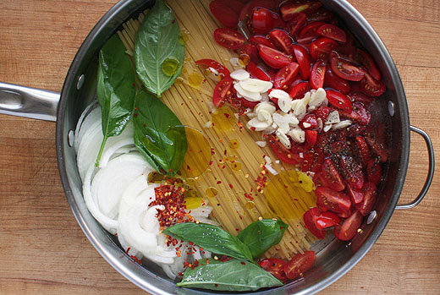Combine pasta, tomatoes, onion, garlic, red-pepper flakes, basil, oil, 2 teaspoons kosher salt, 1/4 teaspoon pepper, and water in a large straight-sided skillet.

Bring to a boil over high heat. Boil mixture, stirring and turning pasta frequently with tongs, until pasta is al dente and water has nearly evaporated, about 9 minutes.

Season to taste with salt and pepper, divide among 4 bowls. Garnish with basil. Serve with oil and Parmesan.

Caramelized Peach & Whole Wheat White Chocolate Oatmeal Skillet Cookie Pie

|  |  |  |
| --- | --- | --- |
| I**NGREDIENTS** | Shopping List (for 6) | Cost |
| 2 tablespoons butter | ShopRite Butter - Salted – (2 stick pack) | 3.00 |
| 4-5 medium peaches and/or nectarines | 4-5 medium peaches and/or nectarines | 5.00 |
| 1 1/3 cup brown sugar | Domino Brown Sugar - Golden Light | 2.00 |
| 1 3/4 cups + 2 tbsp old fashioned oatmeal | ShopRite Old Fashioned Oats (42 oz) | 3.00 |
| 1 1/2 cups white whole wheat flour | ShopRite Whole Wheat Flour (5lb) | 3.00 |
| 3/4 teaspoon baking soda | Baking soda | - |
| 1/4 teaspoon salt | Salt | - |
| 3/4 cup coconut oil melted (or canola) | Jamaican Choice Coconut Oil | 4.00 |
| 2 eggs | Dozen Eggs | 2.00 |
| 1 tablespoon + 2 teaspoons vanilla extract | Vanilla extract | - |
| 1/2 cup slivered or chopped almonds | ShopRite Almonds – Slivered (6oz) | 4.00 |
| 4-6 ounces white chocolate chopped | Lindt Classic White Chocolate | 4.00 |
|  |  |  |
| Total | ($5 per person) | $30.00 |

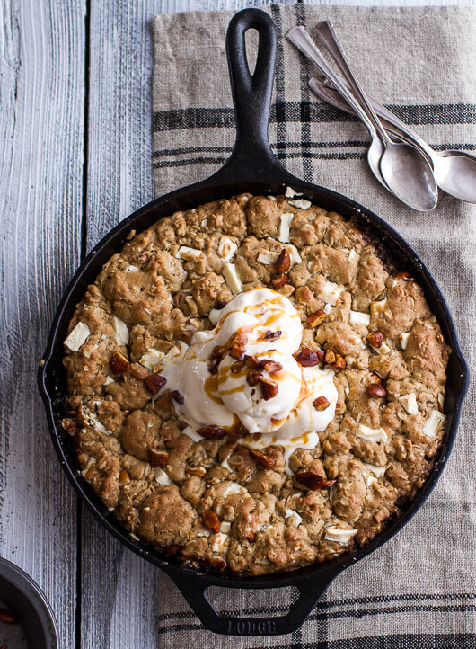Preheat the oven to 350 degrees.

Heat a 10- to 12-inch ovenproof skillet over medium heat; add 1 tablespoon of the butter. Add the sliced peaches, and sprinkle with brown sugar. Cook 3 minutes; stir peaches, and cook another 2 to 3 minutes or until caramelized and soft. Remove from the heat; add 1 tablespoon of the vanilla. Toss well.

In a large mixing bowl add the oatmeal, white whole wheat flour, brown sugar, baking soda, salt, melted coconut oil, eggs and 2 teaspoons vanilla.

Beat until combined and the dough holds together (the dough will seem oily, this is good). Mix in the almonds and about 1 cup of the white chocolate.

Sprinkle the dough directly over the peaches and or nectarines.

Do not worry if there are a few patches where there is no cookie dough. It does not have to be perfect, the dough will fill out as it bakes.

Bake for about 20-25 minutes, just do not over bake. Underdone is always better in my opinion. Remove from the oven and let sit 5 minutes.

Garlic Shrimp Pasta

|  |  |  |
| --- | --- | --- |
| I**NGREDIENTS** | Shopping List (for 4) | Cost |
| 1 lb medium shrimp, deveined/tails removed | 1 lb frozen shrimp | 11.00 |
| 1 lb spaghetti | 1 box spaghetti | 2.00 |
| 6 -8 garlic cloves, minced | Polaner Chopped White Garlic - 4.5oz | 3.00 |
| 1/4 cup butter | ShopRite Butter - Salted – (2 stick pack) | 3.00 |
| Olive Oil (drizzles) | Olive Oil | - |
| Italian Seasoning | Italian Seasoning | - |
| Salt & Pepper | Salt & Pepper | - |
| Red Pepper Flakes | Red Pepper Flakes | - |
|  |  |  |
| Total | ($5 per person) | $19.00 |

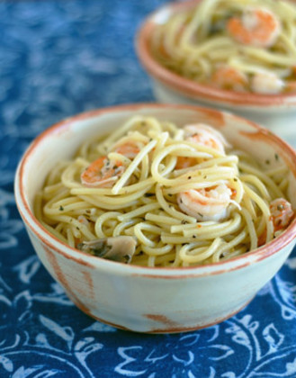Boil pasta in water till tender, save 1 cup of pasta water for use later. I always put some oil, salt, and fresh herbs in with my pasta when I boil it.

Drain and set aside when done. While pasta is boiling, wash shrimp.

Melt butter over medium heat. Add shrimp. Let cook till a little pink and starting to curl. Then add garlic.

Cook 5-7 min, add oil. Continue to stir till shrimp is pink and curled.

Add pasta to skillet. Add seasonings. Add just enough saved pasta water till it is not dry but not swimming in liquid either.

Depending on amount of pasta this requires 1/2 the cup or all of it. Start with adding 1/4 of it then work up from there. Keep tossing all ingredients around in skillet till all is incorporated and hot.

Dutch Oven Lasagna

|  |  |  |
| --- | --- | --- |
| I**NGREDIENTS** | Shopping List (for 8) | Cost |
| 2lb Chopped Meat | 2lb Chopped Meat | 6.00 |
| 1 large onion | 1 large onion | 2.00 |
| 2 teaspoon garlic | Polaner Chopped White Garlic - 4.5oz | 3.00 |
| 2 jars spaghetti sauce | 2 jars Colonna Marinara Pasta Sauce | 3.00 |
| 2 teaspoons Italian seasoning | Italian seasoning | - |
| ½ teaspoon of black pepper | Salt & Pepper | - |
| ½ teaspoon of salt | 2 eggs | 2.00 |
| 2 eggs  30 oz ricotta cheese  No boil lasagna noodles  1 cabbage  6 cups mozzarella cheese | ShopRite Ricotta Cheese (32 oz)  1 box Barilla Oven-Ready Lasagna Pasta 1 green cabbage  1 Great Lakes Shredded Mozzarella 32oz 1 Shopright shredded mozzarella 8oz | 5.00 3.00  2.00  8.00  2.00 |
|  |  |  |
| Total | ($5 per person) | $39.00 |

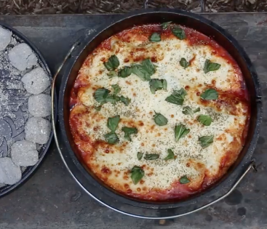

Combine 2lb chopped meat and 1 cup of onions and 2 teaspoons of minced garlic in a hot Dutch Oven, when cooked remove from heat to a bowl.

Add 2 jars of spaghetti sauce, black pepper, salt and Italian Seasoning and mix together with the chopped meat.

In a separate bowl mix together 2 eggs and ricotta cheese.

In Dutch oven, lay a foundation of cabbage, and a layer of sauce mixture followed by a layer of noodles and then cheese mixture followed by a layer of mozzarella. Repeat with remaining ingredients.

Bake for 45 minutes at 350 (8 coals under, 17 coals on top – recommended).